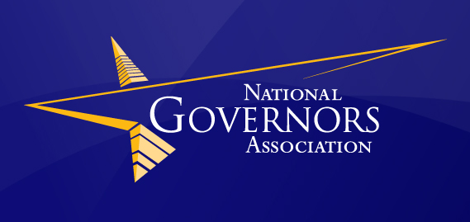

National Governors Association Policy Academy on Prescription Drug Abuse Prevention
State of Nevada Plan to Reduce Prescription Drug Abuse

Executive Summary

The abuse of prescription drugs is the fastest growing drug problem in the United States (U.S.), and prescription drugs are now the second most abused drug after marijuana among teens. Approximately 100 people die every day in the U.S. from drug overdoses, with opioid pharmaceuticals being the leading cause of fatal overdose, surpassing both heroin and cocaine. The Substance Abuse and Mental Health Services Administration’s National Survey on Drug Use and Health (NSDUH) found that more accidental deaths are a result of drug overdose as compared to car accidents.

In order to address this serious problem, the National Governor’s Association (NGA) launched its Prescription Drug Abuse Reduction Policy Academy to assist states with developing a strategic action plan for reducing prescription drug abuse tailored to each state’s unique needs. In 2012, the National Governor’s Association (NGA) launched the first Prescription Drug Abuse Reduction Policy Academy, 7 states participated in this year-long initiative: Alabama, Arkansas, Colorado, Kentucky, New Mexico, Oregon, and Virginia. This academy proved so effective, it was continued.

Nevada was one of 7 states selected to participate in the 2014 Prescription Drug Abuse Reduction Policy Academy along with Michigan, Minnesota, North Carolina, Wisconsin and Vermont. The 2014 Policy Academy is co-chaired by Governor Brian Sandoval and Vermont Governor Peter Shumlin, in partnership with the Centers for Disease Control and Prevention (CDC) and the Association of State and Territorial Health Officials (ASTHO).

Nevada established a Taskforce to research prescription drug abuse and related issues including, community education, medical provider education, criminal justice interventions, and screening and treatment. The Taskforce began its work in September of 2014. During the course of their work, the held a number of meetings with NGA Staff, and state based and national subject matter experts. The Taskforce researched best practices from other states. The Taskforce organized a statewide stakeholder meeting that took place over two days and engaged approximately 200 stakeholders, and interested individuals from all over Nevada. The taskforce recommended policy changes, and with the leadership of Governor Sandoval, was able to introduce and pass SB459 which made substantial policy changes regarding prescription drug abuse prevention in Nevada. The Taskforce adopted the following mission statement in order to guide their work and the State’s vision of prescription drug abuse prevention,

“To reduce prescription drug abuse in Nevada by 18% by 2018 by changing attitudes and behaviors of Nevadans through better coordinated efforts and statewide leadership.”

In its report, the Taskforce identified recommendations for implementation in various key areas. The Taskforce worked with Department of Health and Human Services Director, Richard Whitley who has recommended that the Multidisciplinary Prevention Advisory Committee (MPAC) to provide oversight and coordination for the plan implementation. The MPAC will act as an advisory committee to the Substance Abuse Prevention Treatment Agency which will take ownership and act as the primary agency for the implementation of this plan.

Summary of Recommendations

Community Education

Develop and deliver a comprehensive media campaign with a statewide message on prescription drug abuse issues and applicable sections of SB459.

Develop and deliver specialty trainings and education for various agencies and organizations.

Develop consumer education on prescription drugs.

Medical Provider Education

- Inform medical providers about policy changes that will affect them with the passages of SB459.

Provide education and trainings to prescribers regarding policies and regulations related to SB459.

Data

Determine baseline data.

Create an ongoing plan to evaluate prescription drug prevention and treatment efforts in Nevada.

Create a public data dashboard to track indicators on prescription drug use.

Use data collected to recommend policy changes and funding decisions in the State.

Screening and Treatment

Identify the capacity of treatment program in the community to treat persons with prescription drug problems. Develop a plan to address identified shortages and gaps.

Identify and make recommendations of standardized screening tools that can be utilized across disciplines. Require SBIRT/ early intervention screenings with developmental milestones and key intervention points.

Develop and enhance referral processes between screening sources and treatment centers.

Identify funding for treatment.

Investigate the need for more funding of Medication-Assisted Treatment.

Criminal Justice Interventions

Identify and work towards best practices for working with adjudicated offenders with prescription drug problem.

Identify and expand on current best practices regarding the continuum of care from incarceration to release.

Expand on criminal justice interventions regarding prescription drugs in the community.

Coordination of Efforts

- Create a governing body to oversee the implementation of the Governor’s Prescription Drug Abuse Prevention Plan and to coordinate RX abuse projects in the State.

