ALiS
Centralized Licensing, Inspections and Complaints System (CLICS)
Temporary Events: Consumer Application Instructions

To begin the licensing process, go to https://nvdpbh.aithent.com/login.aspx and then click on the Environmental Health tab. Click on the link “Click Here” under “Apply for a Temporary Food Permit”
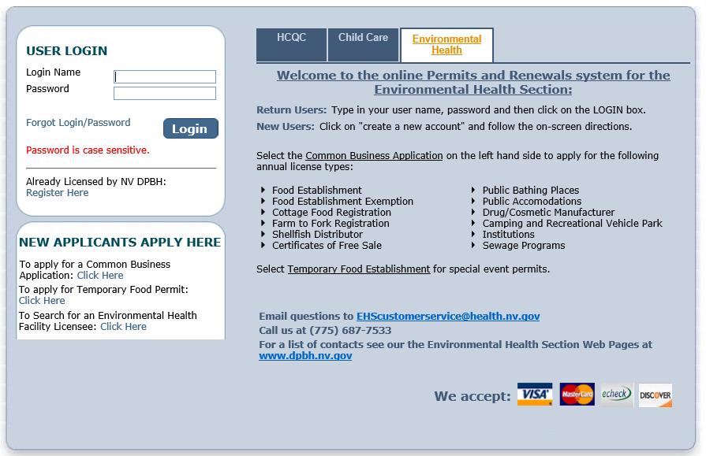

New Applicants
For those who have never used this system it will direct you to set up a Login Name and Password. PLEASE KEEP THIS INFORMATION ON HAND. If you apply for future application you will be signing into the same account to apply for multiple Temporary Event Permits.
Returning Applicants
For those who have already build a profile use the top box “USER LOGIN” to return to your home site to apply for a new permit.

Initial Registration Page:
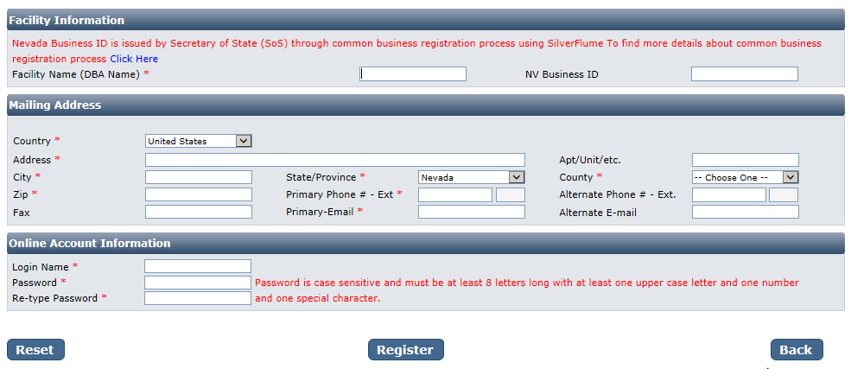
You will need to fill out the following:
- Facility Name (DBA): this should be the registered name of your business.
- NV Business ID: if you have a state business ID, enter it here. It would be “NV” followed by 11 numbers.
- Mailing Address Section:
  - Address is the street address where you receive correspondence for your business
  - City/State/County/Zip: enter the appropriate values that go with the address
  - Phone/Email: this should be the contact information to receive correspondence for your business
- Account Information (Login):
  - The Login Name can be anything using A-Z and 0-9. Take note of it before submitting the form so you don’t forget.
  - Password: must conform to the text in red, for example “MyBusiness.6” contains all the elements needed. Make the password something you can remember, but not easy to guess.
- When you are done with the form, click the Register button.

Application Type: Temporary Events
Select the type of application you would like to apply for then in the area that appears below click the checkbox for the license. You do not need to worry about the risk categories.
IMPORTANT: If you are registering a Temporary Mass Gathering, please contact us at (775) 687-7533. The fee for the application will need to be processed by an Environmental Health Specialist. If you are registering for Burning Man or a Local Event license, proceed using the online system.
When you are finished click the Next button.
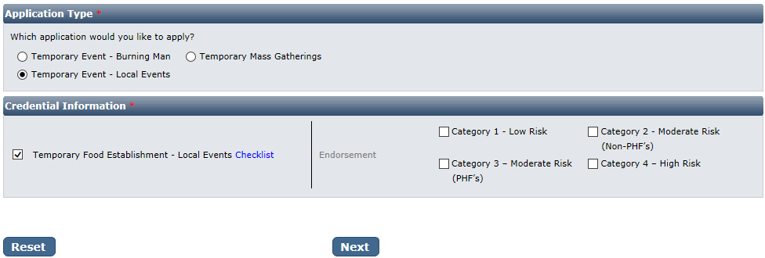

Entity Information:
- Business Entity Information
  - Facility Name (DBA): This will be automatically filled in from your registration, however if you mistyped you may correct it here
  - NV Business ID: This will be automatically filled in from your registration but cannot be changed here
  - Registered Name/Legal Business Name: this should be the exact name on your state business license, if applicable. It may be different from your DBA name.
  - Ownership Type: Select from this list. LLC, Corporation, etc. depending on the business type.
  - Primary Contact Information: The contact information including name, phone, and email should be for the person that will receive correspondence on licensing issues for the business. Their role may be owner, manager, etc.
  - Event Date and Time: Click the “Add” link to add new lines for each day from the beginning to the end of the event. On each line, select the date, select the hours you will be open, and change “Serving Food” setting depending on whether you are serving food or not.
- When you are finished filling out the form, click the Next button.
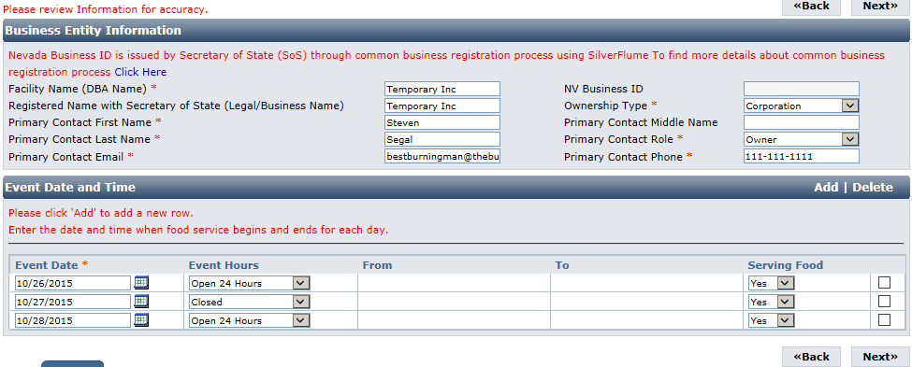

Address Information:
Most of the information in the mailing address section should appear based on what you have entered previously. The mailing address is where correspondence will be sent. When you have entered these click the Next button.
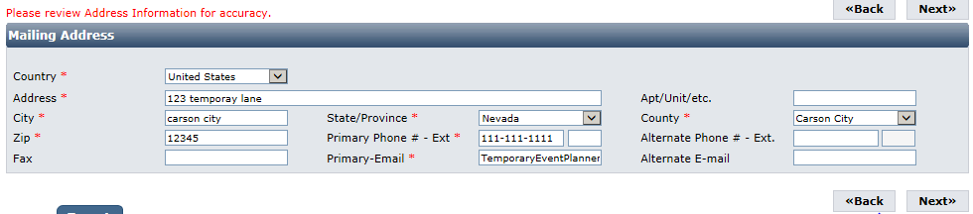

Additional Information:
The Additional Information section will be shown. For a temporary event it will display like this:
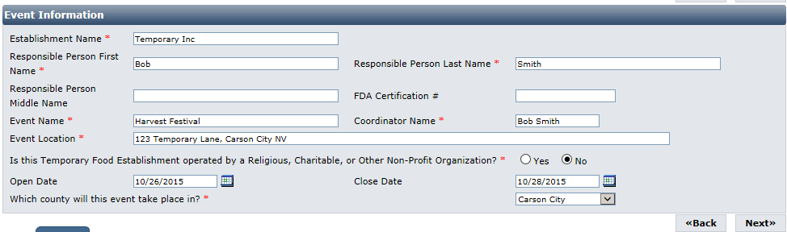

If you are applying for a Burning Man permit, it will display instead like this:
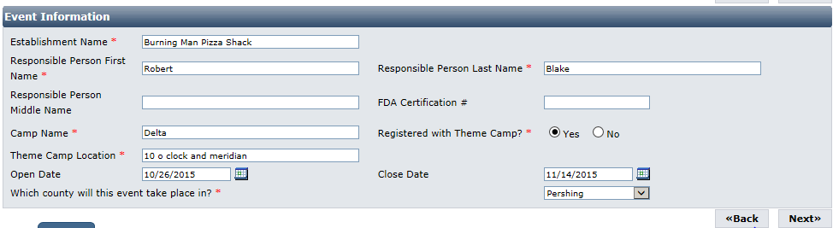

This information is extremely important for accurate records. It has a section for each license with the same fields:
The accuracy of this section will determine the fees charged at the end of the on-line application process.
- Establishment Name: This is the specific name (usually DBA name) for each license. They may be the same or different depending on how the business is structured.
  - Example: The Red Porch Fine Dining
  - Example: Red’s Bar
- Responsible Person: This should be the person-in-charge or owner of the establishment that will be present during an inspection or complaint, and present during the event.
- For Temporary Event Permits:
  - Event Name: enter the name of the event you will be participating in.
  - Coordinator Name: Enter the name of the main event coordinator.
  - Event Location: enter the address where the event will be held.
  - Religious, Charitable, or Non-Profit: Select whether the event falls into one of these categories.
- For Burning Man Permits:
  - Camp Name: The name of the camp your establishment will be associated with.
  - Registered with Theme Camp: Select if you are registered or not with a theme camp
  - Theme Camp Location: If affiliated with a theme camp, list the location of the camp
- Open Date and Close Date: Enter the open and close date for the event.
- County: Select the County that the business is located in. Do not select “All” unless instructed by staff.

This page contains fields that are used by other programs. You may leave them blank if they are not applicable to the facility type.
When you are finished entering all the information for all licenses, click the Next button.

Questions:
This page displays a list of questions that must be answered regarding your facility. A hidden box may pop up requesting more information depending on your answers. When you are finished select the Next button.
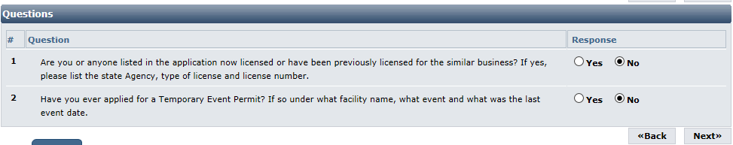

Attestation and Electronic Signature:
Read the legal statements and agree by checking the box to the left. Enter your full name (this is your digital signature) and the current date. When you are done, select “Submit Application”.
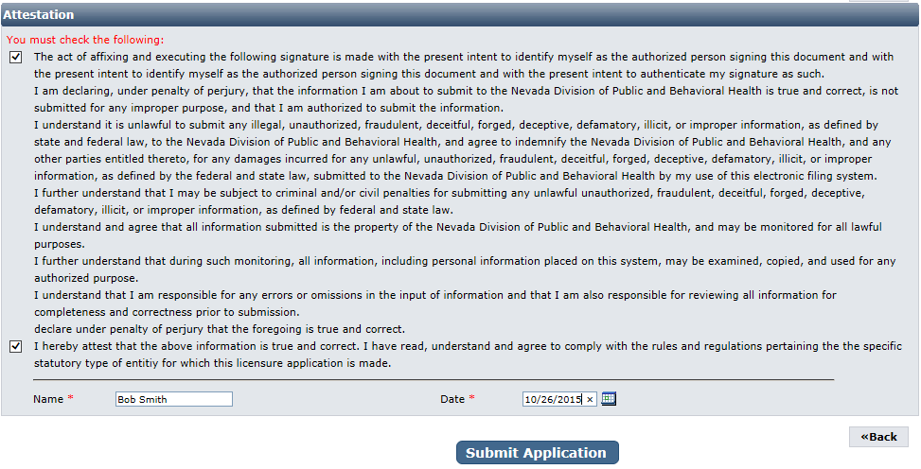

Fee Review
On the next page, the license fee preview will be displayed. Click “Pay Now”.

IMPORANT NOTICE: YOU ARE NOT DONE YET
Checklist: Applications and Documentation
The site will guide you to the checklist and you will need to add your applications and other documentation. Note your transaction number in bold. There is also the option to print the application summary for your records.
Below that section is the list of items that need to be completed for the selected licenses. Some items may be optional depending on your situation. Examine each item carefully and if needed, click the “Documents” link in the View/Attach column on the right side to upload a document for staff review. When you do this, a popup will appear with directions on how to upload your document(s). Example:
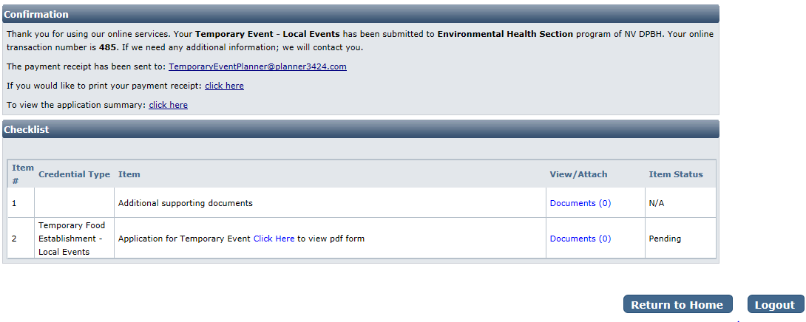
When all required items are uploaded and/or reviewed, your application will be processed.

Returning to complete an application:
To return to your account to complete and application or manage your licenses, go
https://nvdpbh.aithent.com/login.aspx
and then enter your user name and password and then click the Login box:
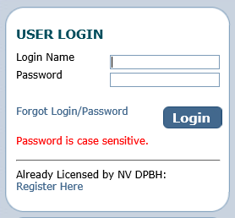
You will see a menu on the left side:
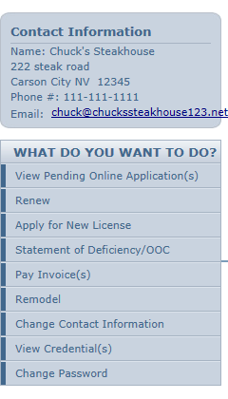
Click on “View Pending Online Application(s)”. You will see a list of applications for review. Select “View Details” for the application you want to look at:
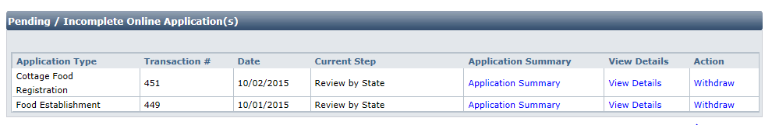

Now you will see the check list again where you can review the status of each item and attach additional documents if needed (the actual items will depend on your license type):
