**Nevada Division of Public and Behavioral Health**

**Burning Man**

**Food Service**

**Guidance Document 2018**

**Who must obtain a permit?**

* Any person or camp wishing to share or serve food to a burner will require a permit no matter the number served.
* Any theme camp or private camp that is serving meals to 125 persons or more.

**When must I submit my application?**

* All permit applications must be submitted before **August 10, 2018.**
* You must obtain your temporary approval for food service before arriving on the playa.
* We do not accept applications on the playa.
* We will not issue permits on the playa.

**Where may I pick up my permit?**

* Permits must be picked up at Playa Info @ Center Camp during the event.
* Permits must be picked up before food service begins.
* Saturday, August 26, 2017 to Wednesday August 30, 2017

From

1:00 Pm To 3:00 PM

**How do I apply for a Burning Man Food Establishment Permit?**

* See our Website at “Temporary Food Establishments at Special Events” 🡪 Burning Man

**Who, what, when, where, how**

If you plan to serve food or share food including certain beverages at Burning Man you need a temporary event permit from the Nevada Division of Public and Behavioral Health (NDPBH), Environmental Health Section.

Our goal is to keep people from getting sick on the playa. We work closely with the Burning Man organization and Bureau of Land Management (BLM) Law Enforcement staff and will request their assistance in closing food operations that have not obtained a valid permit or may cause a public health risk.

This document is intended to inform you of the requirements surrounding food service at Burning Man and help you to prepare and serve safe food at the event. This document is not intended to fully inform you of every provision in the Nevada Administrative Code Chapter 446, Food Establishment Regulations. Knowing and complying with the full set of regulations in order to serve safe food is **YOUR** responsibility. See links in resource section.

**Burning man events contacts**

**Division of Public and Behavioral Health,**

**Environmental Health Section**

**475 West Haskell Street, Suite 38**

**Winnemucca, NV 89445**

**Phone Number: (775) 623-6588**

**Website:**

<http://dpbh.nv.gov/Reg/Temp-E/Temporary_Events_Home/>

**Apply on Line:**

<https://nvdpbh.aithent.com/login.aspx>

**Inspections on the Playa**

**Frequently Asked Questions**

***Question*: What kind of foods are not allowed on the playa?**

***Answer***:

* Food from questionable or unknown sources.
* Food made in the home.
* Home canned foods.
* Potlucks are prohibited.
* Common bowls are prohibited.
* Foods prepared under the Cottage Food Law.
* Food that is vacuum packaged (must be from a commercial source).
* Food that is boiled in a bag (i.e. sous-vide)
* Wild mushrooms.
* Unpasteurized milk or juice
* Raw or undercooked meat, game animals, seafood or eggs.
* Raw live or frozen shellfish such as oysters, clams, mussels or scallops.
* No undercooked foods containing eggs.
* Foods made off site without prior approval.

***Questions*: What food will not require a permit?**

***Answer***:

* Alcoholic beverages: Beer, wine, liquor.
* Commercially prepared, unopened single serving packages that are not refrigerated: chips, candy, soda, bottled water, packaged nuts.
* Whole uncut fruits.
* Powdered drink packages mixed with water only WITHOUT dairy or ice: coffee, tea, hot chocolate, lemonade, PowerAde.
* Shelf-stable commercially prepared beverages such as orange juice or lemonade WITHOUT ice.
* Commercially prepared, unopened popsicles, ice cream bars.

The Environmental Health Section will make every attempt to inspect each permitted food establishment.

**If you are found vending food without a permit, you will be required by Nevada Revised Statute 446 to cease food service.**

**Required Equipment Survival Checklist**

Hand wash set-up (See below)

Three Bucket Dish wash set-up (See below)

Thermometers with a range of 0 to 220 degrees F and at least ______ Probe thermometer check cooking temperatures, hot holding (*Bring Many, they go missing and break easily*)

_______Refrigerator Thermometer(s) - One for each cooler

Sanitizer: Your choice of chlorine (i.e. bleach - either liquid or powdered forms) or quaternary ammonia “quat”.

Sanitizer test strips: Choose the test strip that matches your sanitizer. Available at many restaurant supply or cleaning supply stores. DPBH does not provide these for you. You MUST have these test strips and will be asked to show that you do and that you understand how to use them.

Wiping cloth bucket with sanitizer and/or spray bottle for sanitizer.

Wiping cloths and/or paper towels.

Trash receptacle(s).

Waste water catch bucket(s) to capture waste water from dishwashing and hand washing activities.

Single-use, non-latex food handling gloves.

Ice and an ice scoop with a handle. Do not scoop ice with bare hands or glasses or cups.

Serving and cooking utensils such as tongs, spatulas, spoons, etc.

Coolers, and clean ice chests to refrigerate foods and store bags of ice.

Plenty of potable water for cooking, cleaning, hand washing, etc.

Equipment to heat water.

Cooking equipment.

**Construction of Food Service Camp**

* Locate the stand away from possible contamination sources (showers and port-o-potties).
* Provide a canopy or other form of overhead protection. Secure items from wind damage
* Construct the stand or locate it so that it is protected during bad weather. Try to ensure that the food is adequately protected from weather, dust, and debris.
* Protect food preparation and cooking areas from the public by a shield or separation by distance.
* Food served on a buffet line must be protected from contamination and bare hand contact.
* Handwashing station must be located IN the food preparation area

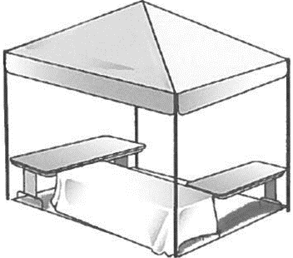

# **Sample of Suggested Set up Under Canopy**

Serving Table

Serving Table

Outside canopy

Under canopy

Food Storage

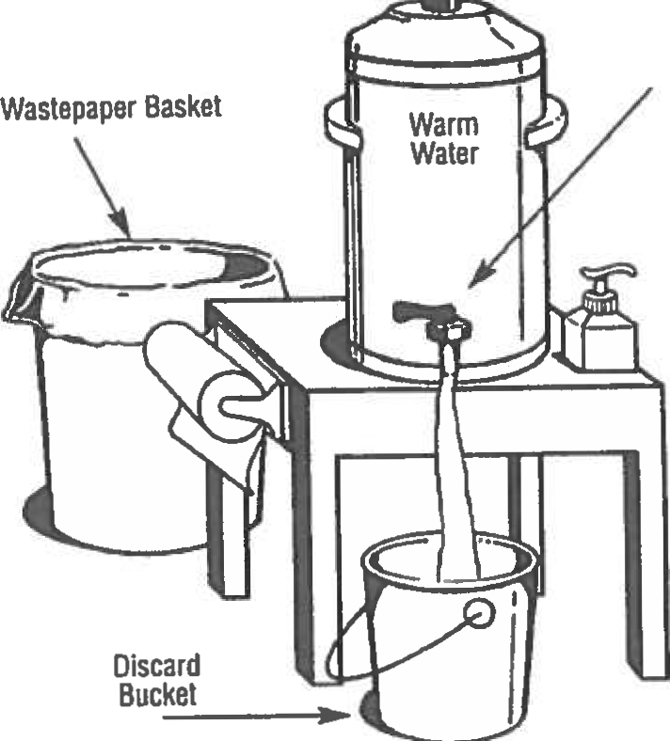

**Personal food areas should not be mixed with food for the public.**

**Do not eat in a food preparation**

**area**

**Beverage consumption is only allowed from a covered container (i.e. lid & straw)**

**A person-in-charge must oversee buffets.**

**Open food must not be left unattended**

**Grill/Stove**

**(Outside Canopy)**

Sanitizer Bucket

Sanitizer Bucket

Food Prep Table

Cooked /Raw Vegetables

Food Prep Table

Raw Items, meat etc.

Food

Preparation

(Cooked)

Food Preparation

(Raw)

**Cleaning Food Preparation Areas**

Set up a sanitizer bucket and wiping cloths to clean down the work area regularly.

Use 2-3 teaspoons of bleach for 2 gallons water. (DO NOT ADD SOAP)

Change the sanitizing water every 2 hours.

A spray bottle may be used for sanitizing surfaces, if overspray does not contaminate food products.

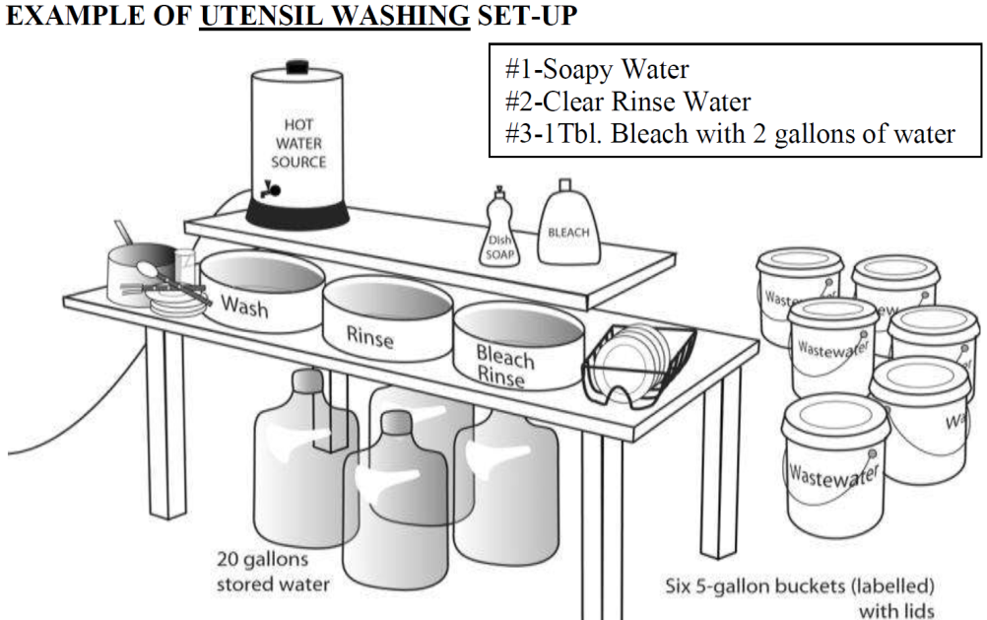

**Water and Waste Water on the Playa**

* Water must be potable.
* Water must be obtained from approved sources such as grocery stores or community water systems.
* Water tanks must be easy to clean, big enough to meet the needs of the food stand, and constructed of an approved, non-toxic material.
* Tanks must be clean and sanitized before fill.
* Bring all water and ice you require with you.
* Prepare to run out of water and ice!
* Bring a disposal container. Dumping wastewater or potable water onto the ground is prohibited.

**Dishwashing Set-ups:**

* Set-up and use a 3 basin sink station and dish drying rack for ware washing.
  + #1 Basin: Wash dishes with soap and warm water.
  + #2 Basin: Rinse dishes in clean water.
  + #3 Basin: Sanitize the dishes. Do not rinse the dishes after sanitizing
* Sanitizer Strength - Test Strips are required to check for sanitizer concentration:
  + Use 50 parts per million (ppm) of a chlorine based sanitizer concentration, or
  + 200-300 ppm of a quaternary ammonia sanitizer.
* Submerge dishes in sanitizer for 1 minute.
* Air dry and cover or store to protect them from dust and dirt.
* In use utensils/work surfaces must be washed, rinsed & sanitized **EVERY** 4 hours.



**Quat Strips (Color: Peach) Chorine Strips (Color: White)**

**Handwashing is one of the most important ways to protect your fellow Burners.**

* Set-up your hand washing station prior to any other kitchen activity.
* The hand sink must have a free-flow spigot/spout and be equipped with liquid pump soap, warm water; paper towels, waste water catch bucket and a trash can for used paper towels.
* Hand sinks may not be used for any other purpose. Dishwashing must be done in separate basin.
* Hand sanitizers may be used after hand washing but DOES NOT replace the need for washing.
* No cloth towels may be used to dry hands. They harbor and spread germs. Use single-service paper towels.
* Wash your hands regularly and often. Wash between breaks, changing gloves and when returning to food service. Immediately after coughing or smoking, when changing food service tasks such as going from chopping vegetables to handling meat, or going from dishwashing or cleaning to food handling.



**Free Flowing Spigot**

**Pump Liquid Soap**

The #1 cause of foodborne illness is contamination of food by dirty hands.

The #2 cause of foodborne illness is sick food service workers

**HANDWASHING FOR 20 SECONDS PREVENTS ILLNESS**

HOW TO PREVENT THE SPREAD OF FOODBORNE ILLNESSES:

* Foodborne illnesses spread quickly and people may carry a pathogen such as Norovirus prior to having symptoms, which is why proper hand washing and wearing gloves is so important!
* TURN ON TAP
* USE A PUMP SOAP
* SCRUB HANDS - FOR 20 SECONDS -
* RINSE HANDS
* TURN OFF TAP WITH PAPERTOWEL
* DRY HANDS ON DISPOSABLE PAPER TOWEL
* SANITIZE SINK FAUCET EACH SHIFT

**DO NOT TOUCH THE FOOD!**

Do not use bare hand contact with ready-to-eat foods. Wear gloves and use tongs, spoons, spatulas, and other utensils when portioning or preparing food. Examples of ready-to-eat foods include all cooked foods, breads, and raw fruits and vegetables that will not be cooked before being eaten.

**20 SECOND IS SINGING “HAPPY BIRTHDAY” 2 TIMES**

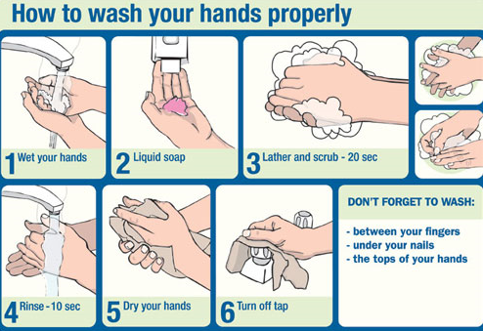



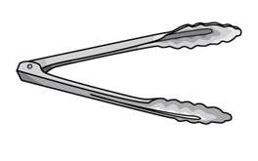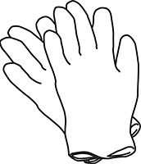



**Healthy and Safe Food Volunteers**

1. Ask if food handlers are feeling well or have been ill with any illness.
2. Instruct volunteers wash hands before they handle any food or help out in the kitchen and ensure that they wash hands regularly as they work.
3. Be sure that food handlers wear disposable gloves when handling ready-to-eat foods.
4. Wash hands each time gloves are changed.
5. Remind food service volunteers that they may not eat, smoke or care for small children while they are working in the camp kitchen.
6. Camp volunteers who have been ill with vomiting, diarrhea, jaundice or headache with fever must not work in food service for at least 24 hours after their symptoms end.
7. Ensure ill food handlers or those with open cuts, burns, open sores or are excluded from food handling, preparation or service.
8. Ensure your employees are properly clothed and clean.

**WARNING FOOD SERVICE BURNERS: If unsafe food handling practices causes a food borne illness outbreak, you may be liable for damages incurred from the resulting illness(s).**

AVOID CONTAMINATION

* Minimize the amount of food preparation in your camp. Examples include using pre­formed hamburger patties and pre-cut and pre-washed vegetables.
* Store foods, drinks and ice in covered containers to protect them from dust and contamination.
* Keep food preparation surfaces clean.
* Store all foods, beverages, serving containers, equipment and ice off the ground by a minimum of 6 inches.
* Store and keep raw animal foods separate from ready-to-eat foods.
* Store different species of raw animal products separately.
* Wash and clean fruits and produce.
* If stored in the same cooler, use separate, sealed containers and store properly. [Top to Bottom: Eggs, Fish, Whole Meat, Ground Beef, Chicken]

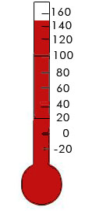

|  |  |  |  |
| --- | --- | --- | --- |
| **CLEAN** | **SEPARATE** | **COOK** | **CHILL** |

**Food Sources**

All food, beverages and ice must be obtained from approved sources.

Off-site preparation or storage must be done at a licensed food establishment and approved in advance. Submit health permit with application.

Read Nevada Administrative Code, Chapter 446 regulating public food service and specifically the section regarding temporary food establishments.

|  |  |  |
| --- | --- | --- |
| **Proper Cooking Temperatures** | **for 15 sec.** | **Examples** |
|  | **145° F** | Fish, shellfish |
|  | **145° F** | Whole-muscle intact meats (steaks), eggs cooked-to-order |
|  | **145° F** | Pork, Pork chops |
|  | **155° F** | Ground beef, sausages, or injected/mechanically tenderized meats, pinned steaks, and scrambled eggs. |
|  | **130°F**  **For 112 min.** | Whole  meat roasts. |
|  | **165°F** | Poultry, stuffed meats, stuffed pasta, stuffed foods with eggs, casseroles |

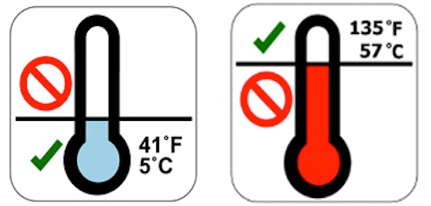

**Safe Food Temperatures**

All food should be kept **cold** or **hot**

* **Keep all temperature sensitive foods cold at or below 41°F. All animal foods, cut fruit or produce, and dairy, etc.**
* **Keep frozen foods frozen.**
* **If using ice to cool or refrigerate food, drain melted ice water regularly to prevent foods from becoming immersed in water.**
* **Keep all cooked foods at or above 135°F.**

**All food should be in covered containers if not being used.**

**If food is kept out of temperature for longer than two hours it must be discarded.**

**Cooling Foods is prohibited, *without prior approval***

Improper cooling and reheating of food is a major cause of foodborne illness!

**Two Step Cooling!**

**Foods prepared ahead of time for later service must be cooled quickly**

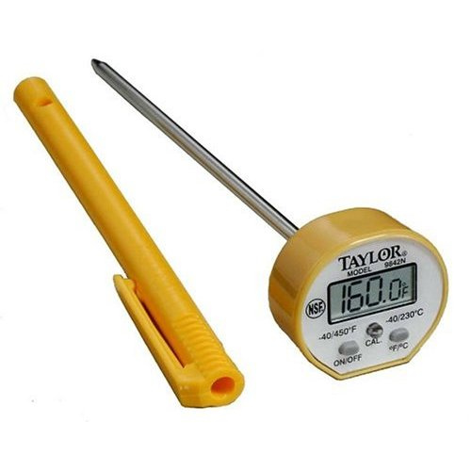

**Bring Stem thermometers to check food and cooling temperatures**

|  |  |  |
| --- | --- | --- |
|  | Cooled quickly from 135°F to 70°F  Transfer food into a cool shallow pan (2 inches or less), then use ice sticks, Ice as an ingredient, or frequent stirring. | 2 hours |
|  | Then down to 41° (check temperatures at 4 and 6 hours)  Then maintain at 41°F or less continuously. | 4 hours |

**Start each day in your camp with fresh food. Discard all leftover cooked food products. Reheating is prohibited. Menu items should be cook and serve, simple food menus prevent the need to cool or reheat.**

**Apply on-line for your Burning Man Application!**

**Deadline: for applications is August 10, 2018**

Nevada Division of Public and Behavioral Health Website

[www.dpbh.nv.gov](http://www.dpbh.nv.gov)

Temporary Food Establishments at Special Events INFORMATION web page

<http://dpbh.nv.gov/Reg/Temp-E/Temporary_Events_Home/>

On-line application INSTRUCTIONS for

Centralized Licensing and Inspections On-Line Applications (CLICS)

<http://dpbh.nv.gov/Reg/CLICS/CLICS_-_Home/>

APPLY on line for Burning Man Permit at

<https://nvdpbh.aithent.com/login.aspx>

ASK For Assistance

[EHScustomerservice@health.nv.gov](mailto:EHScustomerservice@health.nv.gov)