state of nevada
department of Health and human Services – Division of public and behavioral health
Tuberculosis PREVENTION and control Program
Catalog of federal domestic assistance (cfda) number: 93.116
Funding Opportunity Announcement (Foa) Number: PS10-1005
GRANT NUMBER: 5U52PS907855-23

FINAL progress report for 2014

march 31, 2015

The Nevada TB Program Overview:

The mission of the Nevada Division of Public and Behavioral Health’s Tuberculosis Elimination and Control Program is to prevent, control, track, and ultimately eliminate tuberculosis (TB) in the citizens and residents of Nevada. The Nevada TB Program is made up of the Nevada Division of Public and Behavioral Health; three local health districts including Southern Nevada Health District (SNHD), Washoe County Health District (WCHD), and Carson City Health and Human Services (CCHHS); the Nevada State Public Health Laboratory (NSPHL); the Nevada Division of Public and Behavioral Health’s Public Health and Clinical Services (PHCS) Program; the Department of Corrections; and all agencies, organizations and health professionals interested in advancing Nevada’s progress toward improving our TB prevention and control measures.

Nevada is the 7th largest state in the nation with a large majority of the state being vast, sparsely populated areas. Although the 7th largest in mass, Nevada is the 9th least densely populated state in the nation. The state is composed of 17 counties that cover over 110,000 square miles. Of the 17 counties in Nevada, three are considered urban (Clark, Washoe, and Carson City), one is considered rural (Douglas), and the 13 remainder are considered frontier. Areas with a “frontier” designation are defined as having 7 persons or less per square mile. Nevada’s frontier and rural counties account for only 10.7% of the state’s population, but 86.9% of the state’s land mass. Most of Nevada’s rural and frontier communities are located a considerable distance from the state’s major urban area health centers, illustrating the challenges of serving these residents. Nye County, located in the southern region of the state, is the third largest area county in the continental United States and has only 2.3 persons per square mile. Over two-thirds of the state’s population is concentrated in Clark County (containing the Las Vegas metropolitan area).

Nevada’s racial/ethnic composition based on the 2010 Census data is: 66.2% White, 8.1% Black or African American, 7.2% Asian, 1.2% American Indian and Alaska Native, 0.6% Native Hawaiian & Other Pacific Islander, 12.6% Other and 4.7% from two or more races. Nevada’s Hispanic or Latino population makes up 26.5% of the population. Nevada has great cultural diversity. Las Vegas is a minority majority city. As minority populations (specifically foreign-born) tend to have disproportionately higher rates of TB (due to high TB incidence rates in their countries of origin) and are more likely to be uninsured or underinsured, Nevada will need to prepare for the increased demand on its existing infrastructure, to provide appropriate medical services to control the spread of TB.

Nevada’s TB Programs are staffed as follows:

Nevada Division of Public and Behavioral Health – Tuberculosis Elimination and Control Program:
Camy Retzl, State TB Controller.

Southern Nevada Health District (Clark County)
TB Surveillance:
Marlo Tonge, Communicable Disease Manager
Victoria Burris, Communicable Disease Supervisor
Arthuro Mehretu, Communicable Disease Supervisor
Haley Blake, Sr. Disease Investigation and Intervention Specialist
Kim Hertin, Sr. Disease Investigation and Intervention Specialist
Jennifer Harmon, Disease Investigation and Intervention Specialist (DIIS)

TB Clinic:
Richard Cichy, Community Health Nurse Manager
Laurie Hickstein Community Health Nurse Supervisor
Jacqueline Arnold and Michelle Villanueva, Community Health Nurse Case Managers
Regena Ellis, Sheri Fritzman, and Matia Guest, one vacant position Community Health Nurses (CHN)
Sheila Gutierrez, Licensed Practical Nurse
Kim Ogren, Senior Administrative Clerk
Enrique Lopez, Administrative Assistant

Washoe County Health District
Lisa Lottritz, TB Program Manager
Diane Freedman, TB Program Coordinator
Judy Medved-Gonzalez, TB Clinic Case Manager PHN
Holly McGee, Case Manager
Victoria Nicolson-Hornblower, TB Public Health Nurse.

Carson City Health and Human Services (Carson City, Storey, Lyon and Douglas Counties)
Nicki Aaker, Director
Roni Galas, Clinical Services Manager
Dustin Boothe, Disease Control and Prevention Manager
Elaine Bergenheier, Public Health Investigator

Public Health and Clinical Services Program (PHCS) currently has 14 Community Health Nurses on staff, which coordinates the care for TB and LTBI patients in the remaining 12 counties.

Nevada Epidemiological Profile:

In line with the CDC’s goal to promote and protect the nation’s health (Healthy People 2020), Nevada’s Tuberculosis Program, in accordance with Nevada Revised Statutes, supports TB prevention and control activities across the State.

Nevada identified 74 new active cases of TB in 2014, (case rate of 2.7 per 100,000 population and a five-year average of 92 new cases per year). Nevada’s case count declined from 92 new active cases identified in 2013.

The State of Nevada’s Tuberculosis Program is facing many significant challenges in addressing its mission of reducing the incidence of TB through the aggressive management of newly diagnosed cases and extensive preventative treatment of those infected with TB. Most notable are two cases in high schools, multiple MDR-TB cases, and multiple active cases involving international travelers which required multi-state and multi-nation investigations.

Our local, state, and federal correctional facilities also experienced active cases, suspect cases, a multistate outbreak, and many LTBI patients who required consultation and monitoring during incarceration and after release by our local health authorities. The State TB Controller, who is the designated Correctional Liaison, conducts annual site visits of every state and federal correctional facility in the state and provides training and technical guidance within these facilities. Local facilities are visited on an as needed or as requested basis. In past years, Nevada had a Public Health Advisor who coordinated these efforts and actively worked to increase and improve communication and collaboration between the health authorities and the correctional facilities within their jurisdictions. Our Public Health Advisor relocated to a neighboring state, and has yet to be replaced, which has increased the burden on the state program which is staffed by a single FTE (the State TB Controller). Washoe County has had long-standing relationships with the detention facilities in their area and continues to have successful communication and partnerships. Nevada has also seen elevated volume in cases transferred to the facilities under the jurisdiction of the Public Health and Clinical Services arm of Nevada’s TB program, which, despite separation by hundreds of miles, have been managed very effectively.

Prevention and Control Activities from January 1, 2014 through December 31, 2014
*All data is pulled from the National Tuberculosis Indicators Project (NTIP), and the data is current as of February 11, 2015.

Goal 1: Improve treatment completeness among identified cases of Tuberculosis

National Objective 1.1: For patients with newly diagnosed TB for whom 12 months or less of treatment is indicated, increase the proportion of patients who complete treatment within 12 months to 93.0%

State Program Status: Unknown

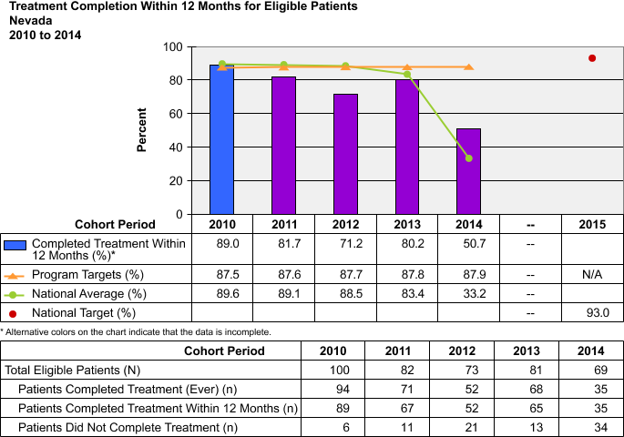
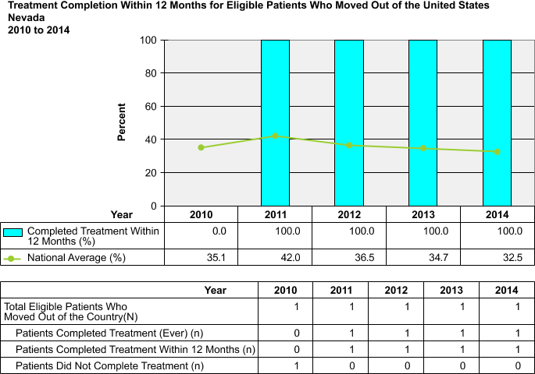

Five Year Target Objectives For: Improving Treatment Completeness Objective
2005-09 National Average | 2005-09 Nevada Average | 2010 Objective | 2011 Objective | 2012 Objective | 2013 Objective | 2014 Objective | 2015 National Objective
 |  | 87.5 | 87.6 | 87.7 | 87.8 | 87.9 | 93.0

Discussion: As the standard treatment regimen for TB is 6 months or greater, analysis of 2014 completion rates will not be available for evaluation until well in to 2015. Nevada’s TB staff is well-trained, persistent, and as accommodating as possible to the needs of patients on treatment. Incentives and enablers are utilized to improve completion rates, yet we continue to struggle with meeting our goals. The complexities of the cases seen in Nevada have extended treatment regimens not only for some of our active cases, but for some LTBI regimens; therefore, the adherence to treatment has been more difficult to sustain. Nevada has consistently performed near the national average for this objective, but has faced challenges with staffing levels and non-adherent clients. In fact, we have had multiple patients actively evade us for treatment, due to misperceptions that their legal or criminal status would be a factor. We work to educate patients that public health works independently of law enforcement. Yet, we are not always successful as some patients do not complete treatment due to this concern. On the newly captured data for COT for patients who moved out of the country, we have achieved 100 percent completion for years 2011 through 2014. Completion rates are of top priority to us, and we will continue to pursue every possible option to ensure that regimens for active cases are fully completed.
Goal 2: Decrease TB Case Rates

National Objective 2.1:
- Decrease the TB case rate in U.S. - born persons to less than 0.7 cases per 100,000.
- Increase the average yearly decline in TB case rate in U.S.-born persons to at least 11.0%.

Status: Unmet & Met, respectively

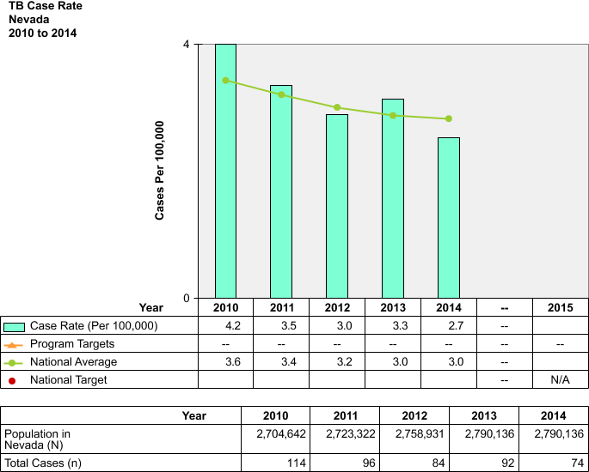

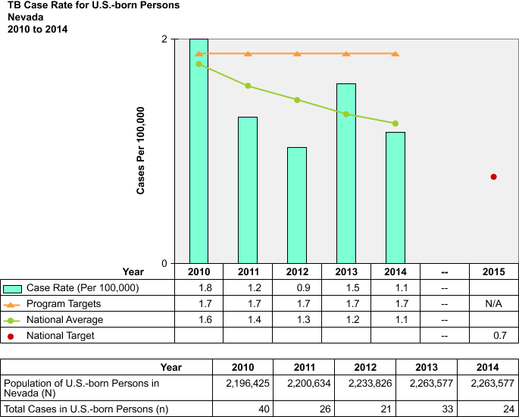

Five Year Target Objectives For: Nevada’s U.S. Born Case Rate Objective
2005-09 National Average | 2005-09 Nevada Average | 2010 Objective | 2011 Objective | 2012 Objective | 2013 Objective | 2014 Objective | 2015 National Objective
2.08 | 1.62 | 1.71 | 1.70 | 1.69 | 1.68 | 1.67 | 0.7

Discussion: Approximately one-third of Nevada’s cases are U.S. born. Nevada had been experiencing a decline in TB cases in this population over the past several years and had maintained a case rate below the national average. In 2013 and 2014, that trend did not continue. Many people are deferring seeking healthcare during Nevada’s economic crisis, and this may have resulted in missed/delayed diagnosis and/or exclusion from treatment. The Nevada TB program needs additional resources to be able to go out and find cases that are being missed due to not being able to attain healthcare, and to provide targeted and comprehensive education to healthcare workers to reduce delays in diagnosis, which is a substantial issue in Nevada. Fortunately, Nevada has seen less active TB cases in 2014 than in 2013, and therefore, we have met the Objective 2.1 of increasing the average yearly decline of case rates.

National Objective 2.2:
- Decrease the TB case rate for foreign-born persons to less than 14.0 cases per 100,000.
- Increase the average yearly decline in TB case rate in foreign-born persons to at least 4.0%.

Status: Met

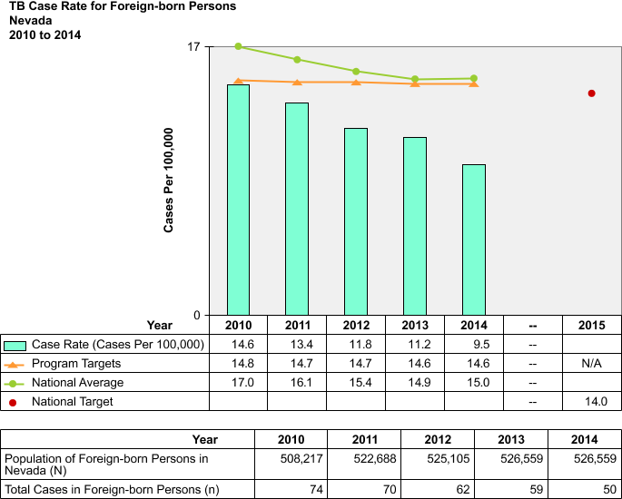

Five Year Target Objectives For: Nevada’s Foreign Born Case Rate Objective

2005-09 National Average | 2005-09 Nevada Average | 2010 Objective | 2011 Objective | 2012 Objective | 2013 Objective | 2014 Objective | 2015 National Objective
19.9 | 14.9 | 14.8 | 14.7 | 14.7 | 14.6 | 14.6 | 14
Discussion: Approximately two-thirds of Nevada’s TB cases are foreign-born. In 2014, 68 percent of our cases were born outside of the United States. Our case rate in this category was lower than it has been in 5 years and was substantially below the national average. Nevada has been able to sustain a fairly constant number in this population and maintain a rate below the national average. In Washoe County (Reno area), the highest yield of active cases comes from immigrants and refugees, who by definition are foreign. Nevada has noted decreasing case rates in this population overall, which may be in part attributable to our challenged state economy. Many of our foreign-born workers have been displaced through unemployment and have migrated back to their homelands. We anticipate that upon economic recovery, we will see a return of this population to fill the needs of the recovering industries in our state. Further, we believe that the modification and legalization of immigration policies will cause a new influx of cases in this population. Nevada must maintain its TB infrastructure to prepare for this bounce back.

National Objective 2.3: Decrease the TB case rate in U.S.-born non-Hispanic blacks to less than 1.3 cases per 100,000.

Status: Unmet

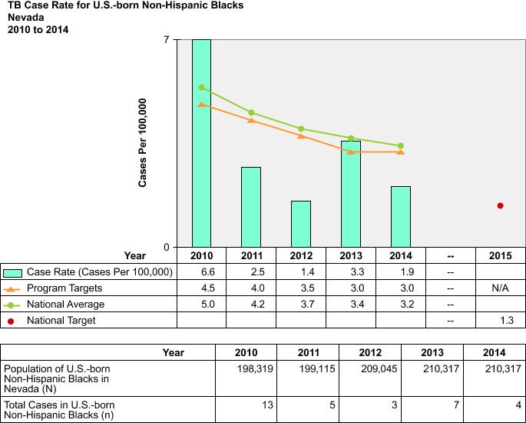

Five Year Target Objectives For: Nevada’s U.S.-Born non-Hispanic Case Rate Objective

2005-09 National Average | 2005-09 Nevada Average | 2010 Objective | 2011 Objective | 2012 Objective | 2013 Objective | 2014 Objective | 2015 National Objective
7.16 | 4.2 | 4.5 | 4 | 3.5 | 3 | 3 | 1.3

Discussion: Nevada’s rate among this population has consistently been below the national average for this objective; however, we have not yet met the national objective. Nevada also has a Black and African American population that is below the national average, which contributes to this statistical showing. Nevada’s spike in 2010 was due to an outbreak among members of a gang whose membership primarily consisted of African-American youths. We expect continuous improvement to be seen in this population as a result of active educational and outreach efforts following our elevated rate in 2010.

National Objective 2.4: Decrease the TB case rate for children younger than 5 years of age to less than 0.4 cases per 100,000.

Status: Unmet

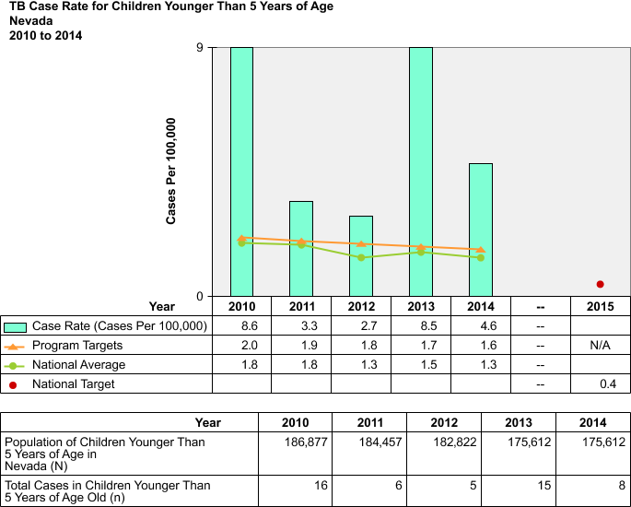

Five Year Target Objectives For: Nevada’s Children Younger Than 5 Years Case Rate Objective

2005-09 National Average | 2005-09 Nevada Average | 2010 Objective | 2011 Objective | 2012 Objective | 2013 Objective | 2014 Objective | 2015 National Objective
2.26 | 2.98 | 2.0 | 1.9 | 1.8 | 1.7 | 1.6 | 0.4

Discussion: Nevada continues to suffer from a pediatric TB rate well above the national average. Our elevated TB rate is the area of primary concern to the State TB program due to the fact that is has remained consistently elevated for many years. In 2013 and 2014 we have experienced multiple pediatric cases, including deaths. We are aware that the pediatric rate is an indicator of the overall disease rate in our state and are increasing efforts to accelerate outreach and education efforts to pediatricians, educators, parents, and caregivers. We will continue to use received funding to support these critical efforts on an ongoing basis.

Goal 3: Improve Contact Investigations

National Objective 3.1:
Increase the proportion of TB patients with positive acid-fast bacillus (AFB) sputum-smear results who have contacts elicited to 100.0%.

Status: Unknown

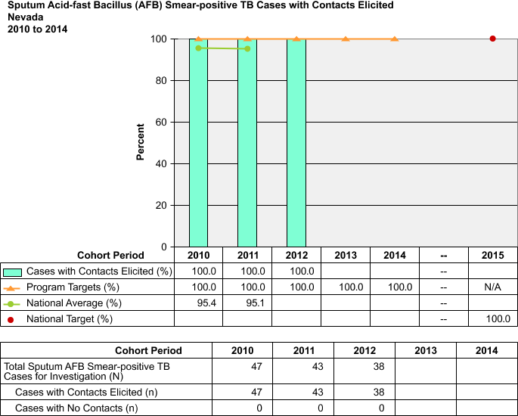

Five Year Target Objectives For: Percent of TB Cases with Contacts Elicited Objective

2006-08 National Average | 2006-08 Nevada Average | 2010 Objective | 2011 Objective | 2012 Objective | 2013 Objective | 2014 Objective | 2015 National Objective
92.76 | 100 | 100 | 100 | 100 | 100 | 100 | 100

Discussion: The standard of care in Nevada is to conduct a contact investigation interview on every pulmonary case of TB regardless of the smear result; all household contacts of extra-pulmonary cases are evaluated for infection. If TB is diagnosed post-mortem, the family, friends and coworkers are interviewed and those contacts are evaluated for infection. Since 2001, Nevada has not had a single pulmonary case that did not have contacts identified; however, we are currently missing data for years 2013 and 2014.

National Objective 3.2: Increase the proportion of contacts to sputum AFB smear positive TB patients who are evaluated for infection and disease to 93.0%.

Status: Unknown
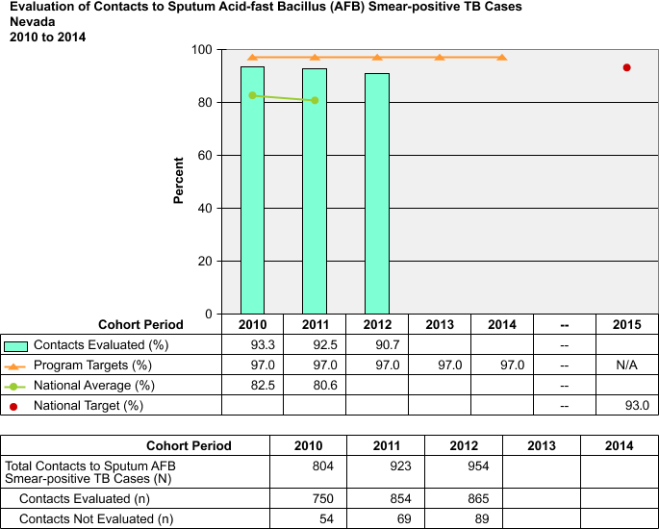

Five Year Target Objectives For: Percent of TB Contacts Who Receive an Evaluation

2006-08 National Average | 2006-08 Nevada Average | 2010 Objective | 2011 Objective | 2012 Objective | 2013 Objective | 2014 Objective | 2015 National Objective
81.3 | 93.9 | 97 | 97 | 97 | 97 | 97 | 93

Discussion: In order to obtain complete evaluations, Nevada’s TB program continues to actively pursue all contacts identified. To expedite the evaluation process, the use of IGRAs has been utilized whenever possible and we are encouraging the expansion of this screening methodology, especially in high-risk populations. The use of incentives and enablers and educating contacts on the importance of knowing their status in order to make informed decisions regarding prophylactic therapy are two methods used to elicit participation in evaluation screenings. Nevada can most likely achieve the national goal of 93% for this objective by 2015, but as of the completion date of this report there is no known data for 2013 and 2014.

National Objective 3.3: Increase the proportion of contacts to sputum AFB smear-positive TB patients with newly diagnosed latent TB infection (LTBI) who start treatment to 88.0%

Status: Unknown

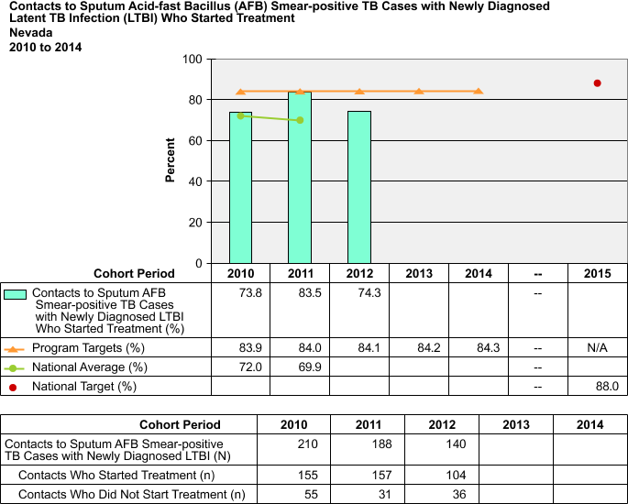

Five Year Target Objectives For: Percent of TB Contacts Who Start an LTBI Treatment Regimen

2004-06 National Average | 2006-08 Nevada Average | 2010 Objective | 2011 Objective | 2012 Objective | 2013 Objective | 2014 Objective | 2015 National Objective
72.2 | 64.8 | 83.9 | 84 | 84.1 | 84.2 | 84.3 | 88

Discussion: Preventative therapy is not mandatory, but highly recommended to all persons diagnosed with latent TB infection (LTBI) in Nevada. The LHA’s educate contacts about LTBI treatment options, and provide extensive education and counseling regarding the advantages of completing a treatment regimen for LTBI. They explain possible risks for the development of active TB disease if LTBI treatment is not completed and the protection LTBI therapy may provide. If the contact decides not to participate in a preventative treatment regimen, they are provided information/education regarding the signs and symptoms to be aware of for TB disease and instructed to seek medical attention if they experience these signs and/or symptoms. The TB Program will continue with activities to ensure this objective reaches its highest possible percent participation level. As Nevada elected to participate in the 3HP (Rifapentine/Isoniazid) regimen trial, we are optimistic that the availability of this shortened regimen will improve treatment starts and allow us to achieve the national target by the end of this grant cycle.

National Objective 3.4: For contacts to sputum AFB smear-positive TB patients who have started treatment for the newly diagnosed LTBI, increase the proportion who complete treatment to 79.0%.

Status: Unknown

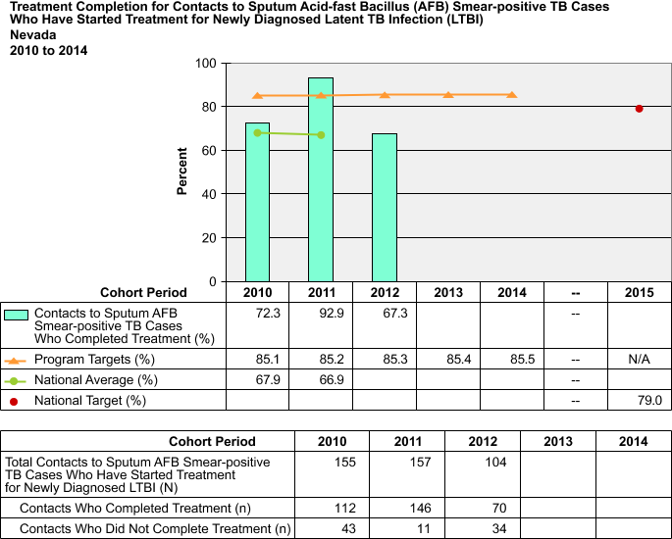

Five Year Target Objectives For: Percent of TB Contacts Who Complete LTBI Treatment Regimen

2004-06 National Average | 2006-08 Nevada Average | 2010 Objective | 2011 Objective | 2012 Objective | 2013 Objective | 2014 Objective | 2015 National Objective
65.9 | 76.2 | 85.1 | 85.2 | 85.3 | 85.4 | 85.5 | 79

Discussion: Preventative therapy is not mandatory, but highly recommended to all persons diagnosed with latent TB infection (LTBI) in Nevada. Whether due to the side effects associated with INH, the extensive time commitment required to complete a treatment regimen (compared to other communicable diseases), the fact that the person does not feel ill, or the individual has differing cultural beliefs and knowledge about the disease/treatment, some contacts decide not to complete preventative therapy for LTBI. Nevada’s TB Program utilizes incentives, enablers, and counseling to address this challenge. Nevada is also one of 22 sites who participated in the 3HP (Rifapentine/Isoniazid) 12-week trials. We are a comprehensive-tier state and expect to be able to evaluate the effectiveness of the alternative regimen on increasing completion. The TB Program will continue with activities to ensure this objective maintains its highest possible percent completion level; however, our program targets are likely not achievable at this time due to the transient nature of our population and the level of patients lost due to leaving the state during our economic crisis.

Goal 4: Improve Laboratory Reporting

National Objective 4.1: Increase the proportion of culture-positive or nucleic acid amplification (NAA) test-positive TB cases with a pleural or respiratory site of disease that have the identification of M. tuberculosis complex reported by laboratory within 25 days from the date that the initial diagnostic pleural or respiratory specimen was collected to 80%.

Status: Met

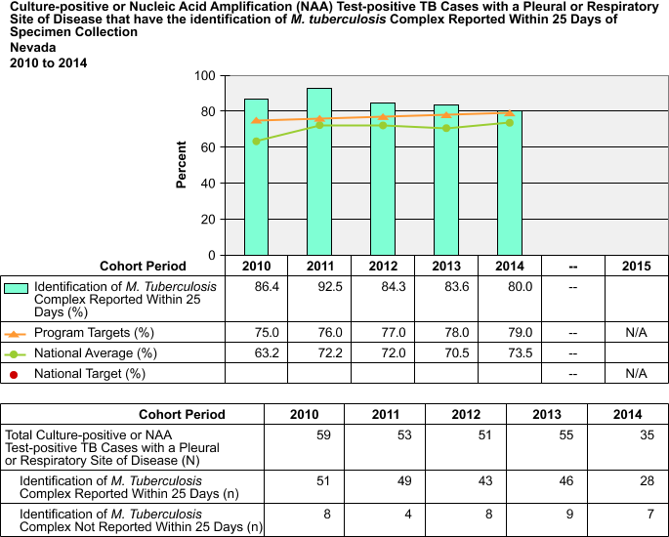

Five Year Target Objectives For: Percent of TB Cases with an Identity of MTBC Reported within 7 Days of Specimen Collection

2009-10 National Average | 2009-10 Nevada Average | 2010 Objective | 2011 Objective | 2012 Objective | 2013 Objective | 2014 Objective | 2015 National Objective
49.1 | 86.9 | 75% | 76% | 77% | 78% | 79% | 80%

Discussion: Nevada State Public Health Lab (NSPHL) is meeting the national objective by performing timely testing and reporting of the nucleic acid amplification test which quickly identifies M. tuberculosis as the AFB seen on a smear when MTB is present in a culture. Nevada is currently meeting the national target percentage.

National Objective 4.2: Increase the proportion of culture-positive TB cases with initial drug-susceptibility results reported to 100.0%.

Status: Unknown

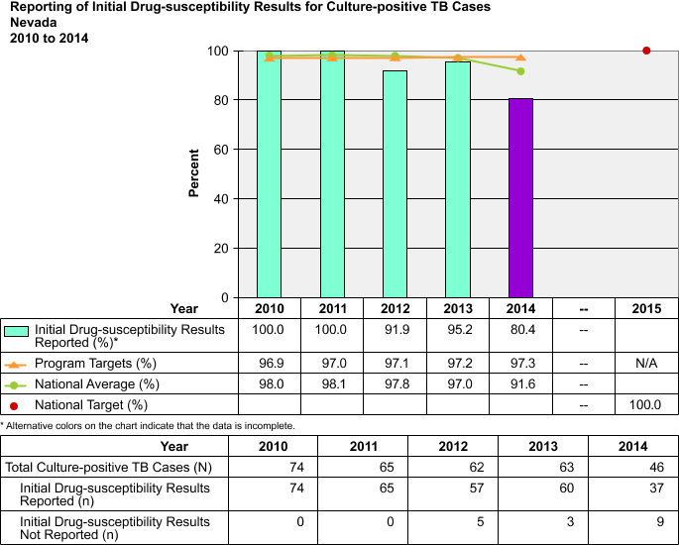

Five Year Target Objectives For: Percent of TB Culture-Positive Cases with Drug-Susceptibility Results Reported

2006-10 National Average | 2006-10 Nevada Average | 2010 Objective | 2011 Objective | 2012 Objective | 2013 Objective | 2014 Objective | 2015 National Objective
95.1 | 97 | 96.9 | 97 | 97.1 | 97.2 | 97.3 | 100

Discussion: Nevada has historically ensured that >95% of cultures positive for MTBC receive drug susceptibility testing (DST). Reference laboratories are utilized to assist with attaining susceptibilities when needed. Investigation will be made into the specifics of the barriers which led to this slight reduction in previous levels. At this time, the data for 2014 has not been fully reported; therefore, the status of meeting this objective is currently unknown.

Goal 5: Expedite Treatment Initiation

National Objective 5.1: Increase the proportion of TB patients with positive AFB sputum-smear results who initiate treatment within 7 days of specimen collection to 90%.
Status: Met

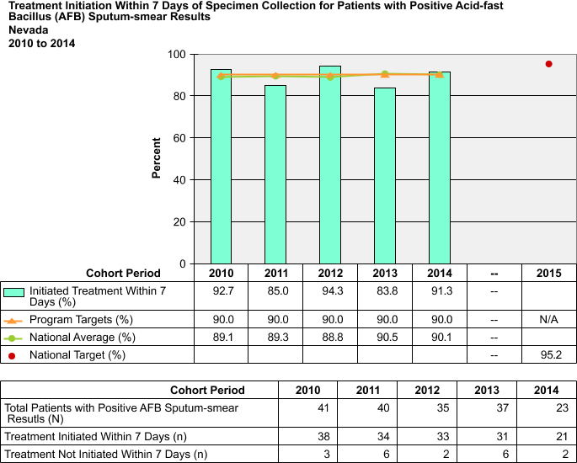

Five Year Target Objectives For: Percent of MTB Suspects with Positive AFB Smears that Begin Treatment within 7 Days of Specimen Collection

2009-10 National Average | 2009-10 Nevada Average | 2010 Objective | 2011 Objective | 2012 Objective | 2013 Objective | 2014 Objective | 2015 National Objective
Not Available | 87.8 | 90% | 90% | 90% | 90% | 90% | TBD

Discussion: The initial diagnosis of TB must be made by assessing the clinical features, patient history, preliminary laboratory results and the chest radiographic examination, and cannot be ruled out just because M. tuberculosis cannot be isolated. Providing technical assistance regarding the importance of starting the standard 4-drug regimen any time the suspicion is high for TB disease has been a goal of the TB Program for many years now. It is evident from this objective that the local programs are successfully educating the health care providers of the importance of “thinking TB” and initiating treatment early in the diagnostic phase. In 2014, we have exceeded both the program and national targets for this objective.

Goal 6: Improve Sputum Culture Conversion Rates

National Objective 6.1: Increase the proportion of TB patients with positive sputum culture results who have documented conversion to sputum culture-negative within 60 days of treatment initiation to 61.5%.

Status: Unknown

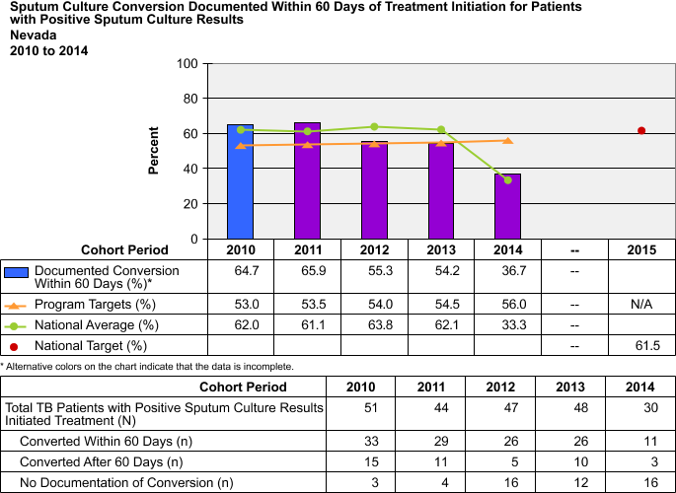

Five Year Target Objectives For: Percent of Sputum Culture Conversions which Occur within 60 Days of Treatment Initiation

2006-09 National Average | 2006-09 Nevada Average | 2010 Objective | 2011 Objective | 2012 Objective | 2013 Objective | 2014 Objective | 2015 National Objective
53.12% | 61.85% | 53% | 53.5% | 54% | 54.5% | 56% | 61.5%

Discussion: With the complexity of the TB cases being treated in Nevada, extended treatment regimens are not uncommon due to extended conversion times. Additional risk factors a patient may have which could impair absorption and/or efficacy as well as difficulties associated with drug interactions, have also been contributing factors. Nevada is currently working on protocols in multiple counties for ordering blood drug levels and how to interpret the results of these levels. At this time, the data for 2014 has not been fully reported; therefore, the status of meeting this objective is currently, unknown.

Goal 7: Improve the Quality and Completeness of TB Data Reporting

National Objective 7.1: Increase the completeness of each core Report of Verified Case of Tuberculosis (RVCT) data item reported to CDC, as described in the TB Cooperative Agreement announcement to 99.2% by 2015.

Status: Unmet

Variable | RVCT  Fields (old/current) | Nevada 2014 |  |  | Complete (%)
 |  | (N) | Unknown  Missing (n) | Complete  (n)
Date of Birth | 7 / 8 | 74 | 0 | 74 | 100.0
Race | 10 / 11 | 74 | 0 | 74 | 100.0
Country of Origin | 11 / 12 | 74 | 1 | 73 | 98.6
Month-Year Arrived in U.S. | 12 / 13 | 50 | 0 | 50 | 100.0
Status at Diagnosis of TB | 13 / 15 | 74 | 1 | 73 | 98.6
Previous Diagnosis of Tuberculosis | 14 / 7 | 74 | 0 | 74 | 100.0
Major Site of Disease | 15 / 16 | 74 | 2 | 72 | 97.3
Sputum Smear | 17 | 74 | 2 | 72 | 97.3
Sputum Culture | 18 | 74 | 7 | 67 | 90.5
Culture of Tissue and Other Body Fluids | 20 | 74 | 2 | 72 | 97.3
Nucleic Acid Amplification Test Result | NA / 21 | 74 | 2 | 72 | 97.3
Chest X-ray | 21 / 22 | 74 | 3 | 71 | 95.9
Tuberculin Skin Test at Diagnosis | 22 / 23 | 74 | 6 | 68 | 91.9
HIV Status | 23 / 26 | 74 | 1 | 73 | 98.6
Initial Drug Regimen | 27 / 37 | 73 | 0 | 73 | 100.0
Date Therapy Started | 28 / 36 | 73 | 0 | 73 | 100.0
Initial Drug Susceptibility Results | 33 / 39 | 46 | 9 | 37 | 80.4
Susceptibility Results | 34 / 40 | 37 | 0 | 37 | 100.0
Sputum Culture Conversion Documented | 35 / 41 | 33 | 17 | 16 | 48.5
Date Therapy Stopped | 36 / 43 | 73 | 32 | 41 | 56.2
Reason Therapy Stopped | 37 / 44 | 73 | 32 | 41 | 56.2
Directly Observed Therapy | 39 / 47 | 73 | 33 | 40 | 54.8
TOTAL |  | 1,493 | 150 | 1,343 | 90.0

Five Year Target Objectives For: Percent of Complete RVCT Data Reported to CDC

2004-08 National Average | 2004-09 Nevada Average | 2010 Objective | 2011 Objective | 2012 Objective | 2013 Objective | 2014 Objective | 2015 National Objective
Not Available | 95.9% | 94% | 95% | 96% | 97% | 98% | 99.2%

Discussion: The state program manager issues monthly MUNK reports to all counties in an effort to ensure completeness of all RVCT data. We have addressed the challenges in this area, including some internal issues with our electronic reporting system, and expect to see marked improvement in future periods.

National Objective 7.2: Increase the completeness of each core Aggregated Reports of Program Evaluation (ARPEs) data items reported to CDC, as described in the TB Cooperative Agreement announcement, to 100%.

Status: Unmet

Variable | RVCT  Fields (old/current) | Nevada 2014 |  |  | Complete (%)
 |  | (N) | Unknown  Missing (n) | Complete  (n)
Date of Birth | 7 / 8 | 74 | 0 | 74 | 100.0
Race | 10 / 11 | 74 | 0 | 74 | 100.0
Country of Origin | 11 / 12 | 74 | 1 | 73 | 98.6
Month-Year Arrived in U.S. | 12 / 13 | 50 | 0 | 50 | 100.0
Status at Diagnosis of TB | 13 / 15 | 74 | 1 | 73 | 98.6
Previous Diagnosis of Tuberculosis | 14 / 7 | 74 | 0 | 74 | 100.0
Major Site of Disease | 15 / 16 | 74 | 2 | 72 | 97.3
Sputum Smear | 17 | 74 | 2 | 72 | 97.3
Sputum Culture | 18 | 74 | 7 | 67 | 90.5
Culture of Tissue and Other Body Fluids | 20 | 74 | 2 | 72 | 97.3
Nucleic Acid Amplification Test Result | NA / 21 | 74 | 2 | 72 | 97.3
Chest X-ray | 21 / 22 | 74 | 3 | 71 | 95.9
Tuberculin Skin Test at Diagnosis | 22 / 23 | 74 | 6 | 68 | 91.9
HIV Status | 23 / 26 | 74 | 1 | 73 | 98.6
Initial Drug Regimen | 27 / 37 | 73 | 0 | 73 | 100.0
Date Therapy Started | 28 / 36 | 73 | 0 | 73 | 100.0
Initial Drug Susceptibility Results | 33 / 39 | 46 | 9 | 37 | 80.4
Susceptibility Results | 34 / 40 | 37 | 0 | 37 | 100.0
Sputum Culture Conversion Documented | 35 / 41 | 33 | 17 | 16 | 48.5
Date Therapy Stopped | 36 / 43 | 73 | 32 | 41 | 56.2
Reason Therapy Stopped | 37 / 44 | 73 | 32 | 41 | 56.2
Directly Observed Therapy | 39 / 47 | 73 | 33 | 40 | 54.8
TOTAL |  | 1,493 | 150 | 1,343 | 90.0

Five Year Target Objectives For: Percent of Complete ARPE Data Reported to CDC

2004-08 National Average | 2004-09 Nevada Average | 2010 Objective | 2011 Objective | 2012 Objective | 2013 Objective | 2014 Objective | 2015 National Objective
Not Available | 100% | 100% | 100% | 100% | 100% | 100% | 100%

Discussion: Nevada will continue to strive to report 100% complete ARPE data in all areas as described in the TB Cooperative Agreement.

National Objective 7.3: Increase the completeness of each core Electronic Disease Notification (EDN) system data item reported to CDC, as described in the TB Cooperative Agreement announcement, to 90%

Status: Unmet

Variable | RVCT  Fields (old/current) | Nevada 2014 |  |  | Complete (%)
 |  | (N) | Unknown  Missing (n) | Complete  (n)
Date of Birth | 7 / 8 | 74 | 0 | 74 | 100.0
Race | 10 / 11 | 74 | 0 | 74 | 100.0
Country of Origin | 11 / 12 | 74 | 1 | 73 | 98.6
Month-Year Arrived in U.S. | 12 / 13 | 50 | 0 | 50 | 100.0
Status at Diagnosis of TB | 13 / 15 | 74 | 1 | 73 | 98.6
Previous Diagnosis of Tuberculosis | 14 / 7 | 74 | 0 | 74 | 100.0
Major Site of Disease | 15 / 16 | 74 | 2 | 72 | 97.3
Sputum Smear | 17 | 74 | 2 | 72 | 97.3
Sputum Culture | 18 | 74 | 7 | 67 | 90.5
Culture of Tissue and Other Body Fluids | 20 | 74 | 2 | 72 | 97.3
Nucleic Acid Amplification Test Result | NA / 21 | 74 | 2 | 72 | 97.3
Chest X-ray | 21 / 22 | 74 | 3 | 71 | 95.9
Tuberculin Skin Test at Diagnosis | 22 / 23 | 74 | 6 | 68 | 91.9
HIV Status | 23 / 26 | 74 | 1 | 73 | 98.6
Initial Drug Regimen | 27 / 37 | 73 | 0 | 73 | 100.0
Date Therapy Started | 28 / 36 | 73 | 0 | 73 | 100.0
Initial Drug Susceptibility Results | 33 / 39 | 46 | 9 | 37 | 80.4
Susceptibility Results | 34 / 40 | 37 | 0 | 37 | 100.0
Sputum Culture Conversion Documented | 35 / 41 | 33 | 17 | 16 | 48.5
Date Therapy Stopped | 36 / 43 | 73 | 32 | 41 | 56.2
Reason Therapy Stopped | 37 / 44 | 73 | 32 | 41 | 56.2
Directly Observed Therapy | 39 / 47 | 73 | 33 | 40 | 54.8
TOTAL |  | 1,493 | 150 | 1,343 | 90.0

Five Year Target Objectives For: Percent of Complete EDN Data Reported to the CDC

National Average | Nevada Average | 2010 Objective | 2011 Objective | 2012 Objective | 2013 Objective | 2014 Objective | 2015 National Objective
Not Available | N/A – New variable | 50% | 50% | 51% | 52% | 53% | 100%

Discussion: The Electronic Data Notification System (EDN) system deployed in 2009 by the CDC’s Division of Global Migration and Quarantine (DGMQ) has improved the notification of the Class A, B1, B2, and B3 immigrants and refugees to the State TB Program. EDN reports have been limited and do not provide information specific to this objective at this time. Nevada is dedicated to continuous improvement in this area and considers this population to be a high priority and will ensure that all data is as complete as possible. While we do not anticipate reaching the 100 percent goal by 2015, we are making substantial progress in this area and project that our trend of annual improvement will continue.

Goal 8: Improve the Recommendation of Initial Therapy for TB Suspects

National Objective 8.1: Increase the proportion of patients who are started on the recommended initial 4-drug regimen when suspected of having TB disease to 93.4%.

Status: Met

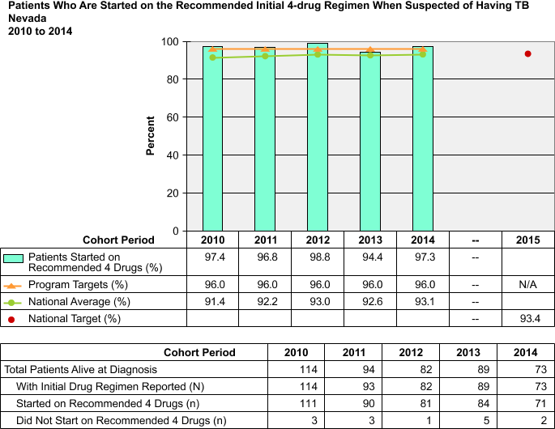

Five Year Target Objectives For: Percent of Suspects Started on 4-Drug Regimen

2006-10 National Average | 2006-10 Nevada Average | 2010 Objective | 2011 Objective | 2012 Objective | 2013 Objective | 2014 Objective | 2015 National Objective
88.4% | 96.7% | 96% | 96% | 96% | 96% | 96% | 93.4%

Discussion: As LTBI is not a reportable disease in Nevada, this objective can only be recorded for suspects that are later confirmed to have active disease and are reported via the RVCT form. Nevada has made it a priority to start suspected TB patients on the standard 4-drug regimen early in the diagnosis process (see objective 5.1 of this report), and has exceeded both the program and national targets for this objective.

Goal 9: Obtain a Genotype for Culture Positive Cases

National Objective 9.1: Increase the proportion of culture-confirmed TB cases with a genotyping result reported to 94.0%.

Status: Unmet
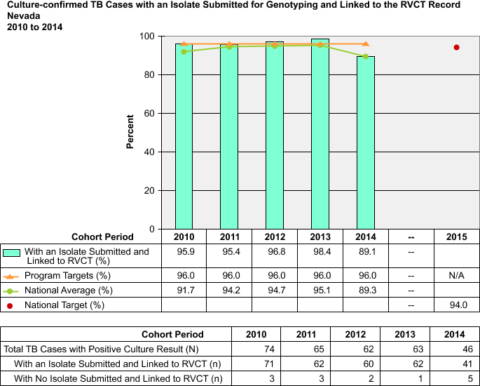

Five Year Target Objectives For: Percent of Culture Positive MTB Cases that have Genotype Reported

2006-10 National Average | 2006-10 Nevada Average | 2010 Objective | 2011 Objective | 2012 Objective | 2013 Objective | 2014 Objective | 2015 National Objective
N/A | 93.2% | 96% | 96% | 96% | 96% | 96% | 94%

Discussion: The NSPHL submits every organism identified as MTBC for genotyping as part of their standard procedure. The super users for the system (State Controller and NSPHL Microbiology Supervisor) are working on reconciling the cases that have missing or unknown data. We expect to be very close to 100% on this objective, and well above the national average by the end of 2015.

Goal 10: Know the HIV Status of TB cases

National Objective 10.1: Increase the proportion of TB cases with positive or negative HIV test result reported to 88.7%.
Status: Met

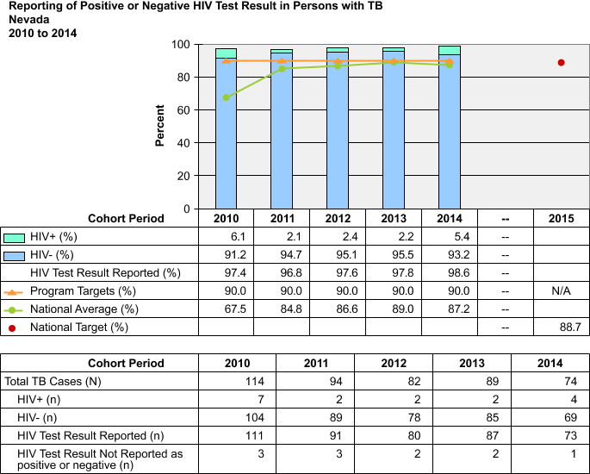

Five Year Target Objectives For: Percent of TB Cases with an HIV Result Reported

2004-08 National Average | 2006-10 Nevada Average | 2010 Objective | 2011 Objective | 2012 Objective | 2013 Objective | 2014 Objective | 2015 National Objective
78.9% | 90.3% | 90% | 90% | 90% | 90% | 90% | 88.7%

Discussion: Nevada’s TB protocols recommend HIV testing for all TB patients, regardless of age. For persons who have died prior to TB diagnosis (or soon after), HIV status is reported if the documented results are available within the last two years. We do occasionally encounter some resistance from an isolated number of patients (very young or elderly) who refuse testing due to stigma or cultural considerations. These patients require additional time and education, but ultimately, the vast majority of all patients have a result reported. The TB and HIV Programs also conduct a data match to verify completeness and accuracy.

Goal 11: Improve Immigrant and Refugee Evaluations

National Objective 11.1: For immigrants and refugees with abnormal chest x-rays read overseas as consistent with TB, increase the proportion who initiate medical evaluation within 30 days of arrival to 20%.

Status: Met

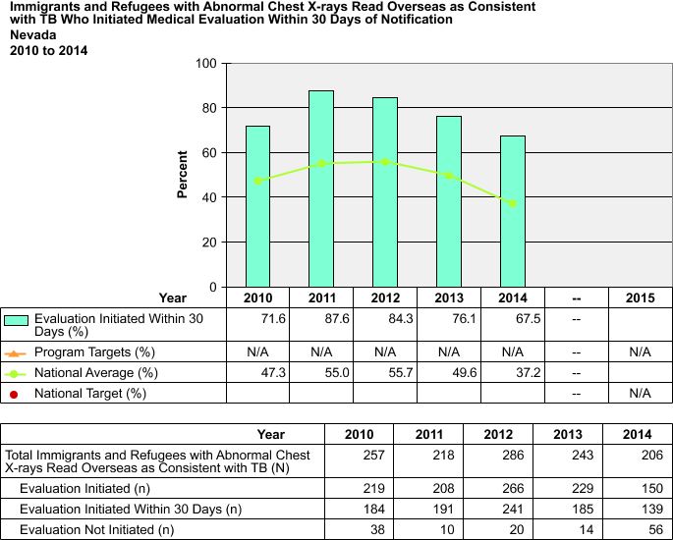

Five Year Target Objectives For: Percent of Immigrants and Refugees with a TB Classification that Receive an Evaluation within 30 Days of Arrival

National Average | Nevada Average | 2010 Objective | 2011 Objective | 2012 Objective | 2013 Objective | 2014 Objective | 2015 National Objective
Not Available | N/A – New variable | 16% | 17% | 18% | 19% | 20% | 20%

Discussion: Nevada’s TB Programs diligently pursue class B notifications to initiate and complete TB evaluations in a timely manner. As this is a known high-risk group which yield active infectious cases every year, targeting this population for complete evaluations is a priority for Nevada.

National Objective 11.2: For immigrants and refugees with abnormal chest x-rays read overseas as consistent with TB, increase the proportion who complete medical evaluation within 90 days of arrival to 45%.

Status: Met

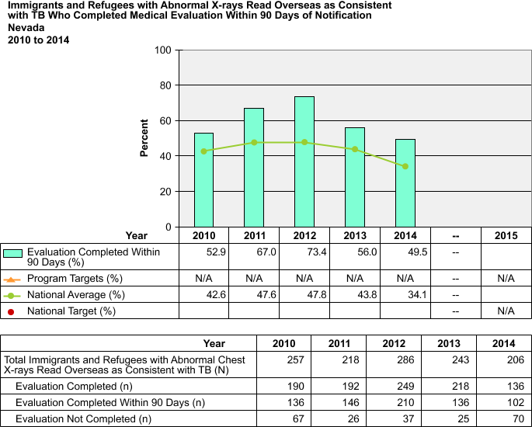

Five Year Target Objectives For: Percent of Immigrants and Refugees with a TB Classification that Complete an Evaluation within 90 Days of Arrival

National Average | Nevada Average | 2010 Objective | 2011 Objective | 2012 Objective | 2013 Objective | 2014 Objective | 2015 National Objective
Not Available | N/A – New variable | 41% | 42% | 43% | 44% | 45% | 45%

Discussion: The Electronic Data Notification System (EDN) system deployed in 2009 by the CDC’s Division of Global Migration and Quarantine (DGMQ) provides notices of arrivals in a timely manner; although, in many of our counties, the immigrants arrive to the clinics before the notices do. Nevada has been able to successfully complete evaluations in the prescribed period for a significant percentage of this population and continues to bolster our efforts to continue improvement. We currently exceed the national average on this goal and expect to see similar results in future years.

National Objective 11.3: For immigrants and refugees with abnormal chest x-rays read overseas as consistent with TB and who are diagnosed with latent TB infection (LTBI) during evaluation in the U.S., increase the proportion who start treatment to 60%.

Status: Met

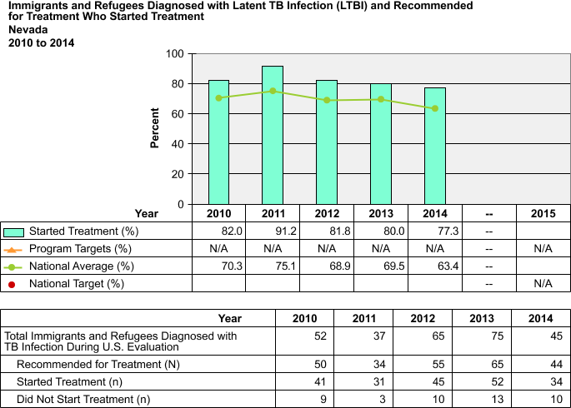
Five Year Target Objectives For: Percent of Immigrants and Refugees Diagnosed with LTBI who Start Treatment

National Average | Nevada Average | 2010 Objective | 2011 Objective | 2012 Objective | 2013 Objective | 2014 Objective | 2015 National Objective
Not Available | N/A – New variable | 50% | 52% | 54% | 56% | 58% | 60%

Discussion: In prior years, Nevada has exceeded the national average on this goal and expects to see similar results in this year once all data is updated.

National Objective 11.4: For immigrants and refugees with abnormal chest x-rays read overseas as consistent with TB, and who are diagnosed with latent TB infection (LTBI) during evaluation in the U.S. and started on treatment, increase the proportion who complete LTBI treatment to 50%.

Status: Unknown
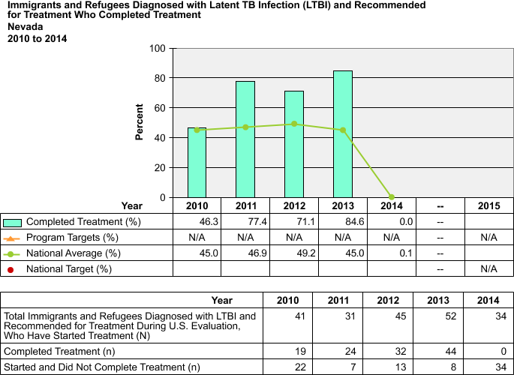

Five Year Target Objectives For: Percent of Immigrants and Refugees Diagnosed with and Started on LTBI Therapy who Complete Treatment Regimen

National Average | Nevada Average | 2010 Objective | 2011 Objective | 2012 Objective | 2013 Objective | 2014 Objective | 2015 National Objective
Not Available | N/A – New variable | 40% | 42% | 44% | 46% | 48% | 50%

Discussion: The Local Health Authorities enter this information directly into the SDN- EDN through the worksheets. Historically Nevada has been well-above the national average on this objective; however, no data for 2014 has been reported on this objective as of yet.

Goal 12: Increase Sputum-Culture Reported

Objective 12.1: Increase the proportion of TB cases with a pleural or respiratory site of disease in patients ages 12 years or older that have a sputum-culture result reported to 95.7%.

Status: Unmet

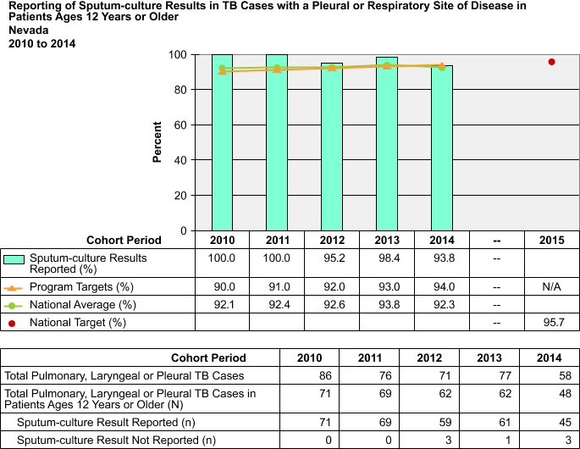
Five Year Target Objectives For: Percent of TB Patients 12 Years or Older that have a Sputum Culture Result Reported

2006-09 National Average | 2006-09 Nevada Average | 2010 Objective | 2011 Objective | 2012 Objective | 2013 Objective | 2014 Objective | 2015 National Objective
91.5% | 98.8% | 90% | 91% | 92% | 93% | 94% | 95.7%

Discussion: In the past, Nevada has consistently exceeded the 95.7% national target for this goal; however, in 2014 we were below the threshold. We will strive to once again achieve the national target for this objective.

Goal 13: Improve Program Evaluations

Objective 13.1: Increase program evaluation activities by monitoring program progress and tracking evaluation status of cooperative agreement recipients.

Status: Met

Discussion: The state controller actively oversees progress of all recipients and receives formal quarterly reports from all recipients in regards to their activities and status. Although, a formal program/fiscal evaluation did not take place during 2014 for the subgrant recipients, it will be a focus for this upcoming year.

Objective 13.2: Increase the percent of cooperative agreement recipients that have an evaluation focal point.

Status: Met

Discussion: The state controller serves as the designated focal point for all counties and Co-Ag recipients in Nevada.

Goal 14: Develop a Human Resource Development Plan

Objective 14.1: Increase the percent of cooperative agreement recipients who submit a program-specific human resource development plan (HRD), as outlined in the TB Cooperative Agreement announcement, to 100.0%.

Status: Met

Discussion: All Co-Ag recipients provided HRD plans and reports during their annual site visits and those plans were evaluated through collaboration with the state controller to best support the needs of the TB program. It will continue to be Nevada’s practice to acquire the HRD plans on an annual basis during the formal site visit.

Objective 14.2: Increase the percent of cooperative agreement recipients who submit a yearly update of progress-to-date on HRD activities to 100.0%.

Status: Met

Discussion: The quarterly reports submitted to the state TB program by the subgrant recipients provide a narrative outlining HRD activities taking place for that region for each quarter. The Nevada program partners work closely together on HRD to ensure appropriate capacity building throughout the program.

Goal 15: Training Focal Point

Objective 15.1: Increase the percent of cooperative agreement recipients that have a TB training focal point.

Status: Met

Discussion: The State Controller is the TB education and training focal point for Nevada and has submitted formalized plans to the CDC to detail our priorities and strategic approaches to them.

NEVADA PUBLIC HEALTH LABORATORY

TB LAB 2014 TOTALS

 | Quarter 1 | Quarter 2 | Quarter 3 | Quarter 4 | TOTAL
WORKLOAD DATA TEMPLATE | JAN FEB MAR | APR MAY JUN | JUL AUG SEPT | OCT NOV DEC
Total specimens processed (no isolate referrals) | 369 | 336 | 443 | 323 | 1471
Total patients cultured | 165 | 150 | 117 | 144 | 576
# pts positive for TB | 16 | 21 | 18 | 9 | 64
# patient referrals (LJ, MGIT, etc) | 27 | 30 | 29 | 23 | 109
# pt referrals positive for TB | 3 | 5 | 13 | 4 | 25
# pts Sensitivity performed | 7 | 19 | 20 | 22 | 68
# PCR performed | 32 | 34 | 32 | 22 | 120
# PCR positive for TB | 3 | 9 | 3 | 1 | 16
# TB sent for genotyping | 9 | 16 | 13 | 10 | 48
IGRA tests performed at NSPHL | 298 | 353 | 625 | 773 | 2,049
TAT DATE TEMPLATE
% specimens rec’d within 24 hours | 45.8% | 44.3% | 53.2% | 43.9%
% specimens rec’d within 48 hrs | 20.6% | 23.5% | 21.0% | 23.2%
%specimens rec’d within 72 hrs | 16.8% | 14.0% | 10.4% | 15.2%
% smears reported within 24 hrs | 92.7% | 94.0% | 95.7% | 98.1%
% smears reported within 48 hrs | 8.6% | 3.0% | 2.9% | 1.2%
% smears reported within 72 hrs | 0.5% | 0.9% | 1.4% | 0.6%
% TB isolates reported within 21 days | 89.19% | 88.0% | 84.16% | 74.0%
% susceptibilities reported within 28 days | 70.0% | 38.9% | 70.0% | 75.0%
# pts TB confirmed within 48 hrs of receipt | 3 | 7 | 3 | 1 | 14
# Patients  Positive NAAT within 48 hours | 3 | 7 | 3 | 1 | 14

