Community Resource Guide

### Southern Nevada Adult Mental Health

### 

### Revised January 2014

### CONTENTS

#### Abuse Services & Crisis Hotlines………………………………………………………………………………... 3

### Chemical Dependency/Recovery Programs…………………………………………………………………….. 3

Women’s Treatment Services………………………………………………………………………………... 4

# ***Non-Professional Residential Programs for Addiction Recovery…*…………………………………………5**

#### Employment and Training Services…………………………………………………………………………….. 5

#### Financial Assistance………………………………………………………………………………………………. 6

#### Food Assistance…………………………………………………………………………………………………… 6

#### Hospice……………………………………………………………………………………………………………. 7

#### Housing……………………………………………………………………………………………………………. 8

#### Legal Assistance………………………………………………………………………………………………….. 9

#### Medical Assistance/Support Services…………………………………………………………………………… 9

#### Mental Health/Counseling/Support Services….….……………………………………………………………. 11

**Peer Support Groups……………………………………………………………………………………………. 13**

##### Rent Assistance…………………………………………………………………………………………………... 13

#### Seniors……………………………………………………………………………………………………………. 14

#### Shelters………………………………………………………………………………………………………...…. 15

#### Transportation…………………………………………………………………………………………………… 15

#### Charitable Services…….………………………………………………………………………………………… 16

#### Out of State Services…………………………………………………………………………………………….. 16

**Welfare Offices…………………………………………………………………………………………………... 16**

**Department of Motor Vehicles (DMV) Offices………………………………………………………………… 17**

**Area Shelter List with Map……………………...……………………………………………………………… 18**

**Southern Nevada Adult Mental Health Outpatient Clinics with Map……..………………………………… 20**

#### Abuse Services & Crisis Hotlines:

#### National Domestic Violence Hotline…………………………………………………………………...800-799-7233

## Child Protective Services Hotline….………………………………………………………………………..399-0081

Child Haven…………………………………………………………………………………….…………...455-5444

Clark County Senior Advocate Program….…………………………………………………………………455-7051

Crisis Call Center…………………………………………………………………(800) 273-8255 or (775) 784-8090

Metro Police Department – Abuse and Neglect Detail…………………………………………………….. 828-3364

National Runaway Switchboard (1-800-RUNAWAY)...…………………………………………......(800) 786-2929

Nevada AIDS Hotline (Nevada AIDS Project)………………………………………………………...……636-1800

## Elder Protective Services…………………………………………………………………………………... 486-3545

To report suspected elder abuse, neglect, exploitation, isolation, and/or complaints………………………………..……486-6930

Family & Child Treatment of Southern Nevada (FACT): Individual, family and group counseling to victims of abuse.

6431 W. Sahara Ave., Ste. 200…………………………………………………………………... 258-5855

The Rape Crisis Center Hotline………………………………………………………..…….Hotline (888) 366-1640

801 S. Rancho Dr., Ste B-2….……………………………..………………….………….................385-2153

S.A.F.E. House: Provides battered women crisis intervention, shelter and counseling…………………..………...Hotline 564-3227

921 American Pacific Dr. Suite 300, Henderson NV 89014……………………………..…….……451-4203

SafeNest: Provides battered women crisis intervention, shelter and counseling. 2915 W Charleston, Ste 12…….……877-0133

National Addiction & Mental Health Helpline – 24 hour hotline ………………………………….. (800) 662-4357

Southern Nevada Area of Alcoholics Anonymous –24 hour hotline....…………………………………….598-1888

Southern Nevada Area of Narcotics Anonymous – 24 hour hotline………………………………………..369-3362

Suicide Prevention Center of Clark County: Survivors of suicide group, Spanish speaking program, and community education.

Nevada Hotline…………………………………………………………………….. (877) 885-HOPE (4673)

#### National Hotline…………………………………………………………………….(800) 273-TALK (8255)

### Victims of Crimes…………………………………………………………..……………………………….486-2740

#### Chemical Dependency/Recovery Programs:

Bridge Counseling – Out-patient & Intensive Out-patient treatment

1640 Alta Drive, Suite 4…………………………………………………………………………….474-6450

Center for Behavioral Health Nevada – Methadone maintenance, Out-patient treatment

EAST – 3050 E Desert Inn Suite 116……………………………………………………………… 796-0660

CENTRAL – 1311 S Casino Center……………………………………………………………...…382-6262

NORTH – 2290 McDaniel St., Suite C.……………………………………………………...……...399-1600

NORTH WEST – 3470 W Cheyenne #400..………………………………………………....……..636-0085

#### Chemical Dependency/Recovery Programs continued:

Choices Group – Outpatient treatment

2725 E. Desert Inn Rd., Suite 180……..….…………………………………………………………252-8342

Community Counseling Center – Out-patient & Intensive Out-patient treatment

714 E. Sahara Ave., Suite 101……………………………………………………………….............369-8700

### Help of Southern Nevada – Youth ages 16-24; housing; substance abuse

1417 Las Vegas Blvd North ….…………………………………………………………………..…385-3776

Foundation for Recovery:

3321 N. Buffalo, Suite 225…..………………………………………………………………………257-8199

Las Vegas Indian Center: Community based adult out-patient substance abuse treatment

2300 W. Bonanza Road……………………………………………………………………………. 647-5842

Las Vegas Recovery Center – In/Out-patient treatment

3371 N Buffalo Dr…………………………………………………………………………………..515-1373

Montevista Hospital – Intensive Out-patient, Medical Detox & Residential treatment

5900 W Rochelle ………………………………………………………………………………….. 364-1111

Office of Substance Abuse Prevention & Treatment Agency

1840 e. Sahara, Suite 111…………..………………………………………………………………..486-8250

Salvation Army – Residential treatment

211 Judsen Avenue ………………………………………………………………………………... 399-2769

Veterans Addiction Treatment……………………………………………………………………………... 791-9000

WestCare Community Involvement Center - Intensive Out-patient treatment

401 S Martin Luther King Blvd……………………………………..………………………………385-3330

WestCare Community Triage – Detoxification

930 N. 4th Street …………………………………………………………………………………… 383-4044

Women’s Treatment Services

WestCare – Women with Children Campus

5659 Duncan Dr …..………………………………….………………………................................. 385-3330

WeCare – Residential treatment; non-professional; no assessment fee

2216 S 6th St………………………………………………………………………………………. 369-0613

Sober Living Las Vegas:

3852 Palo Verde St…………………………………………………………………………………..418-6330

#### Chemical Dependency/Recovery Programs continued:

# ***Non-Professional Residential Programs for Addiction Recovery***

Las Vegas Rescue Mission: Bible based residential treatment

480 W Bonanza Rd…………………………………………………………………………….…... 382-1766

Transitional Living Communities (TLC): 12 Step Based Program; Housing; 90 day program; required to find employment

210 North 10th St…………………………………………………………………………………… 387-1331

**Employment and Training Services:**

Catholic Charities of Southern Nevada: Employment Services Center

1526 N Main St…………..………………………………………………………………………...387-2221

Clark County School District Department of Adult Education: Registration and classes for GED after 4:30 pm at Rancho High School, Garside Jr High School, Desert Rose High School.

2701 E St Louis Ave, Suite A ………………………………………………………………….…. 799-8650

College of Southern Nevada:

3200 E Cheyenne Ave……………………………………………………………………………... 651-4000

6375 W Charleston Blvd…………………………………………………………………………… 651-5000

700 College Dr………………………………………………………………………………………651-3000

For an Independent Tomorrow (F.I.T.) - Empowers motivated unemployed and underemployed Nevadans toward financial stability and self-sufficiency

1931 Stella Lake Drive………….……………………………………………….. 367-4FIT | (702) 367-4348

Neighborhood Service Department

495 S Main Street, 5th Floor, City Hall………………………………………...…………………..……..…229-2330

### Help of Southern Nevada - Rental assistance; Homeless services

1640 E. Flamingo Rd. Suite 100 ….……………………………………………………………..…369-4357

Key Foundation: Vocational services for homeless veterans.

1001 North A St………………………………………………………….……………………….. 384-0202

Las Vegas Indian Center: Native Americans for this service only

2300 W. Bonanza Road……………………………………………………………………………. 647-5842

Nevada Bureau of Vocational Rehabilitation: Vocational services for persons with disabilities.

119 Water Street………………………………………………………………….……………….…486-0300

3016 W Charleston Blvd Suite 200……………………………………………………………….…486-5230

3405 South Maryland Pkwy…………………………………………………………...…………….486-0100

6330 W. Charleston Blvd, Suite 190.………………………….…………………………………….486-6043

2827 Las Vegas Blvd North…………………………...…………………………………………….486-0200

Nevada Department of Employment, Training and Rehabilitation

Web address: <http://detr.state.nv.us> ………………………………………………………………..486-0350

**Employment and Training Services continued:**

Nevada Partners and Culinary training Academy: Comprehensive job readiness training program for the unemployed, underemployed.

710 W. Lake Mead…………………………………………………………………………………. 924-2100

Urban League: Mission is to empower communities and ensure equal opportunity for low-income people; assistance for ex-offenders convicted of a felony; assist individuals with integrating into workforce

930 W Owens………………………………………………………………………………………636-3949

Veteran’s Affairs, Dept of: Telephone assistance service; Benefits information & assistance…..………………800-827-1000

**Financial Assistance:**

Clark County Social Services: Assistance with rent for Temporary Assistance to Needy Families (T.A.N.F.) clients. Also has the GATE Program for able-bodied adults. In return for work for the county, individual or family gets assistance with rent in form of check or voucher issued by Clark County Social Services.

1600 Pinto Lane …………………….………………………………………….………….………...455-4270

2432 North Martin Luther King, Bldg D ……………………….………..………………...….………...455-7208

1501 N. Las Vegas Blvd……………………………………………………………...….…………..455-1990

3885 S. Maryland Pkwy……………………………………………………………………………..455-8639

522 S. E. Lake Mead...…….. ………………………..…………………………………………..….455-7918

|  |
| --- |
|  |

Consumer Credit Counseling Services of Southern Nevada: Free counseling, assistance with debt management plans and classes on money management.

2650 S Jones Blvd………………………………………………………………(800) 451-4505 or 364-0344

Nevada State Welfare: FOR WELFARE OFFICE INFORMATION SEE LAST PAGE

Social Security Administration: Provides a change of address for Social Security Benefit, Application for Social Security disability (SSD), application for Supplemental Income (SSI)

National Toll-Free Number………………………………………………(800) 772-1213 or (866) 614-9667

1250 S. Buffalo Dr,, Ste. 100: ***this is the only Card Center***……...……………………...…..........(800) 772-1213

4340 Simmons St, N Las Vegas…………………………………………..(800) 772-1213 or (866) 614-9667

10416 S Eastern Ave, Henderson…………………………………………(800) 772-1213 or (702) 293-1914

Western Union………………………………………………………………………………….…….(800) 325-6000

**Food Assistance:**

Catholic Charities of Southern Nevada/ Social Services Department: Food Pantry- Monday 8am -3pm. Bring ID on every one in household and proof of residency (i.e. rent receipt or utility bill); Social Security card; Birth certificate

1511 N Las Vegas Blvd…………………………………………………………………….……….387-2291

Catholic Charities – Meals on wheels for individuals 60 yrs or older

531 N 30th St………………………………………………………………………….385-5284

City Mission of Las Vegas: Food Boxes (Sign up on Tue & Wed 930 am-11 am) – Bible Study & free lunch Tuesday, Wednesday & Thursdays 8 am – 12 pm

2214 N Pecos Rd …(Lake Mead Blvd & Pecos)….……………………………………………... 384-1930

**Food Assistance continued:**

### Hope Link Family Resource Center: Food bank Wed 8:30 am – 9:30 am; Utilities & rent if applicable

178 Westminster Way, Henderson…………………………………………………………………..566-0576

Las Vegas Indian Center: Community based adult assistance available to all

2300 W. Bonanza Road……………………………………………………………………………. 647-5842

Las Vegas Rescue Mission: Dinner served at 5pm. everyday

480 W Bonanza Rd…………………………………………………………………………….…... 382-1766

Lutheran Social Services – Food Bank Mon thru Thurs; first come first served open at 7:30 am

73 Spectrum Blvd………………………………………..…………………………………………..639-1730

Nevada 2-1-1

Call from any landline……………………………………………………………………….211 or 369-4357

Salvation Army Dining Hall: Doors open for dinner from 2:45 pm- 3:30pm

35 W Owens Ave……………………………………………………………………………...…….701-5347

St Vincent Lied Dining Facility – Free meals 7 days a week, 10:00 am – 10:30 am

1501 Las Vegas Blvd North...………………………………………………………….……………385-7801

Three Square Food Bank: Mon – Fri 8 am-5 pm

4190 N Pecos Rd……………………………………………………………………………………644-3663

United Methodist Social Services: Weekend emergency food pantry – Sat 9am-1pm & Sun 1pm-4pm

4412 S Maryland Pkwy…….………………………………………………………..………….…...733-0053

Hospice:

Beacon of Hope Hospice

8 Sunset Way, Suite 101 Henderson...………………………………………………………………736-8180

Compassion Care Hospice

7842 W. Sahara……….……………………………………………………………………………..997-6466

Creekside Hospice

3675 Pecos McLeod, Suite 900……………………………………………………………………...650-7669

Family Home Hospice

8655 S Eastern….…………………………………………………………………………...............671-1111

Hospice of Las Vegas Inc

5765 S Rainbow Blvd, Suite 111..…………………………………………………………………..853-9063

Nathan Adelson Hospice

4141 Swenson St…………………………………………………………………………………… 733-0320

Solari Hospice Care

5550 S Jones Blvd………………..……………....………………………………………………….870-0000

**Housing:**

Southern Nevada Regional Housing Authority (Section 8)

340 N 11th Street…………………………………………………………...…………… 922-6800/922-6850

Department of Housing & Urban Development: Subsidized Housing

302 Carson, Suite 400………………...……………………………………………………………..366-2100

Family Promise of Las Vegas: (No walk-ins; Call for assessment for homeless families with minor children; Permanent housing for families with minor children and one adult who is disabled)

320 S 9th St………………………..…………………………………………………………………638-8806

Golden Rainbow: Services through referral only. Referral can be obtained through Aid for AIDS of Nevada (AFAN) or (COMC). Services with referral for low cost housing for people with HIV & AIDS; financial assistance with rent, utilities and medical bills.

801 S Rancho Drive, Suite B -1………………………………………………………………….....384-2899

Housing Authority of the County of Clark, Nevada (Public housing only)

5390 E Flamingo Rd………………………………………………………………………………..451-8041

Las Vegas Indian Center: Community based assistance available to all

2300 W. Bonanza Road…………………………………………………………………………….647-5842

Nevada Homes for Youth: Affordable housing for middle to low-income families; Inpatient/outpatient substance abuse treatment through Probation department

525 S 13th ST…………………………………………………………………………….………... 380-2889

Parson’s Place: Transitional housing for single men, women and couples without children

624 E Stewart…………………………………………………………………….………….……... 383-0847

Sober Living Facilities:

6016 Fawn Ave………………………………………………………………………………….…..353-7279

2021 Pinto Lane……………………………………………………………………………………...456-4020

3852 Palos Verdes….………………………………………………………………………………..418-6330

Southern Nevada Center for Independent Living:

4100 N. Martin Luther King Blvd., Suite 100 …………….………………………………………...649-3822

2950 S. Rainbow Blvd., Suite 220...…………………………………………………………..…….889-4216

Veteran’s Homeless Outreach 7:30 am – 4 pm

926 W Owens (in the Nucleus Plaza) ………… …..……………………………………………….636-4077

Veteran’s Affairs, Dept of: Benefits information & assistance…..……………………………………… (800) 827-1000

Women’s Development Center: Transitional housing program; affordable rental program; independent living program for women over 50 yrs old. For single parents with children willing to work full-time or work part-time and go to school part-time. Client should provide eviction notice and ID for all family members.

4020 Pecos McLeod…………………………………………………………………………………796-7770

Pathways – Salvation Army: Residential Group Home for individuals 18 or older with mental illness.

37 W Owens……….……………………………………………………………………………….639-0277

**Legal Assistance:**

Clark County District Attorney Family Support Division:

1900 E. Flamingo Rd..………………………………………………………………………………671-9200

Civil Law Self-Help Center: Provides legal information – 8 am to 4 pm

200 Lewis Avenue, Regional Justice Center, 1st Floor……………………No phone, please visit in person

Clark County Neighborhood Justice Center: Mediation service with respect to disputes/disagreements.

330 S Third Street, Suite 600………………………………………………….…………………… 455-3898

Clark County Self Help Center: Assistance with forms located on first floor

601 N Pecos Rd…………………………………………………………………………………….455-1500

Disability Action Advocates: Assists with Social Security Disability process and/or supplemental Security Income claims.

3211 W. Charleston Blvd…….………………………………………………………………….…. 892-3564

Disability Lawyers for Social Security Disability

Lori R. Feldman…P.O. Box 33729…Las Vegas…89133-3729………………...………….212-3363 or (877) 222-5630

Legal Aid Center of Southern Nevada: Free legal classes; Domestic violence victims assistance; assistance with Social security application and other legal matters

725 E. Charleston Blvd.………………………………...……………………………………….......386-1070

Metropolitan Police Department Victim Service Detail

400 S. Martin Luther King……….………………………………………………………………….828-2955

Nevada Legal Services:

530 S 6th St………….………………………………………………………………….…………...386-0404

Toll-free Number………………………………………………………………….………….(866) 432-0404

North Las Vegas Police Department Victim/Witness Office

3755 W Washburn.………………………………….………………… ………………………………........633-1017x5084

Senior Citizens Law Project: Clark Co residents over 60yrs. 8:30 am – 5:30 pm

310 S 9th St – 2nd floor (Located on 9th and Bridger)……….………………………………………….…..229-6596

State of Nevada Victims of Crime Program 8 am -5 pm

2200 S Rancho Dr Suite #130 (near Sahara)…………………………………………….......................486-2740

**Medical Assistance/Support Services:**

Aid For AIDS of Nevada (AFAN)

1120 Almond Tree Lane………………………………………………………………..………..…382-2326

American Cancer Society

6165 South Rainbow Blvd…………………...……………………………………………………...798-6877

American Heart Association

4445 South Jones Blvd., Suite B-1…...……………………………………………………….(800)-242-8721

**Medical Assistance/Support Services:**

Clark County Social Services: Medical assistance for those not eligible for State of Nevada Medicaid or Homemakers program.

1600 Pinto Lane …………………….………………………………………….……..….455-4270/455-1990

2432 North Martin Luther King, Bldg D ……………………….………..………………...…………....455-7208

1501 N. Las Vegas Blvd……………………………………………………………...……………..455-4270

3885 S. Maryland Pkwy……………………………………………………………………………..455-8687

522 E. Lake Mead, Henderson...……………………..…………………………………………..….455-7918

Community Outreach Medical Center (COMC) General medical care including prenatal and family planning services.

1140 Almond Tree Lane, Suite 306…………………………………………………………………657-3873

Comfort Keepers: Non-Medical in-home care...2881 Business Park Court, Suite 226…………………………385-1000

Huntridge Teen Clinic: Low cost medical & dental assistance for 12–18 yrs; not Medicaid eligible and have no other insurance

2100 S Maryland Pkwy, Ste 1 and 5……………………………………………………………….. 732-8776

Maxim Health Care Services: Adult home care provider, OT, PT, ST – Medicare/Medicaid

1771 E Flamingo Rd # 216A……………………………………………….……………………… 369-9828

Nevada AIDS Project: Referral Only, Does not accept walk-ins……………….………………….……………...636-1800

Nevada Community Enrichment Program (NCEP): Brain Injury/Neurological Rehabilitation

6375 W Charleston Bldg L200………………………………………………………………………259-1903

Nevada Health Centers: Sliding fee scale for uninsured based on family income. Must bring proof of income, residence, and picture I.D. Additional fees for lab and procedures may apply. Medicare, Medicaid, Nevada Check-Up, CCSS are accepted.

3900 Cambridge Ave. Ste. 102………………………………………..…………………………….307-5415

1799 Mount Moriah Drive …….………………………………………….…………………….......383-1961

2225 Civic Center Drive, Suite 224...……………………………………………………………….214-5948

2212 S Eastern Ave………………………………………………………………………………….735-9334

Southern Nevada Health District: Provides Family Planning – sliding scale, Immunizations – free, Healthy Kids – Medicaid

330 S. Valley View Blvd.………………………………………………………………………….. 759-1000

University Medical Center Lied Ambulatory Care Center (UMC):

1524 Pinto Lane, Las Vegas – Appointments Necessary…………………..………………………..383-2631

University Medical Center (UMC): Emergency medical care.

1800 W Charleston Blvd, Emergency room……………………………………………………….. 383-2000

University Medical Center - Wellness Center 7am – 5 pm

701 Shadow Lane, Suite 200………………………………………………………………………...383-2691

Veteran’s Affairs, Dept of: Benefits information & assistance…..……………………………………… (800) 827-1000

Volunteers in Medicine of Southern Nevada: Free medical clinic for all ages

4770 Harrison Drive, Suite 200.……………………………………………………………………..967-0530

Women’s Resource Medical Center:

2915 W Charleston Blvd., Suite 1………………………………………………………………..…366-1247

**Mental Health/ Counseling/ Support Service:**

ABC Therapy: Bi-Lingual Counseling

730 N. Eastern Ave, Suite 130……………………………………………..…………………….....598-2020

Aid for AIDS of Nevada

1120 Almond Tree Lane………………………………………..…………………………… 382-2326

Behavioral Healthcare Options

2716 N Tenaya………………………………………………………………………………………240-8733

Bridge Counseling: Offers sliding scale. Requires appointment.

1640 Alta Drive, Suite 4…………………………………………………………………………….474-6450

Boulder City Hospital – PHP Partial Hospitalization Program: Mental Health Care

901 Adams Boulevard………………………………………………………………………………294-5757

Center for Behavioral Health:

Las Vegas Family Clinic - 1311 S Casino Center……………………………………………………382-6262

3050 E Desert Inn, Suite 116…...…………………………………………………………………....796-0660

2516 E Lake Mead Ave……………………………………………………………………………...399-1600

3470 W Cheyenne Rd, Suite 400 ……….……………………………………………………….....636-0085

Center for Change: Specialized in eating disorder. Inpatient/Outpatient treatment ….…………………………..…..(888) 224-8250

1790 North State Street, Orem, Utah…………………………………………….…….……..(801) 224-8255

Center for Health & Learning: Counseling services for children, adolescents, & adults

9811 W. Charleston Blvd., Suite 2-345…………………………………………………………….383-6012

Center for Individual, Couple and Family Counseling

UNLV Campus, open Mon –Thur 3 pm-9 pm………………………………………………..…….895-3106

Community Counseling Center: Offers sliding scale. Counseling and support group services

714 E. Sahara Ave., Suite 103……………………………………………………………….............369-8700

Community Resource & Referral Center (For homeless Veteran’s only): Nucleus Plaza

916 W Owens…………………………………………………………………………….…………791-9077

### Desert Regional Center: Services for individuals with mental retardation or developmental disabilities

1391 S Jones Blvd………………………………………………………………………………….. 486-6200

Desert Willow Treatment Center: Services inpatient for children and adolescents

6171 W Charleston Blvd – Bldg 17…………………………………………………………………486-8900

Family & Child Treatment of Southern Nevada (FACT)

6431 W. Sahara, Suite 200…………………………………………………………………………. 258-5855

**Mental Health/ Counseling/ Support Service:**

Harmony Health Care

1701 W Charleston, Suite 300..…………………………………………………………………….251-8000

Human Behavior Institute (HBI):

2740 S Jones……………………………………………………………………………………….. 248-8866

H.O.P.E of Nevada: Educational services for self directed recovery and wellness plans

3941 Copperhead Hills Street……………………………………………………………………….234-9068

Mojave Mental Health: Provides mental health services to any person above the age of 18. MEDICAID ONLY.

4000 E Charleston Blvd……………………………………………………………………………. 968-4000

Montevista Hospital: Provides Outpatient Counseling, Inpatient services, Partial Hospitalization, Outpatient Geriatric services

5900 W Rochelle Ave……………………………………………………………………………… 364-1111

National Alliance for the Mentally Ill (NAMI):

Information Help-line…………………………………….…………………………………...(800) 950-6264

NAMI of So Nevada Help Line....…………………………………………………………………..310-5764

Nevada Early Intervention Services: Provides services for developmentally delayed children 0 – 3 years old.

1161 S Valley View Blvd………………………………………………………………………….. 486-7670

North Vista Hospital – Geriatric Psychiatric Unit: Services for people 55 and older.

1409 E Lake Mead Blvd, 4th floor …………………….………………………………………... 657-5754

Red Rock Behavioral Health Hospital – Services for individuals 55 or older

5975 W Twain Ave………………………………………………………………………………….214-8099

Seven Hills Behavioral Institute: Psychiatric & Substance Abuse Detoxification & Rehabilitation Hospital

3021 W Horizon Ridge Pkwy……………………………………………………………………….646-5000

Southern Nevada Adult Mental Health Services: Sliding scale. Services include: Psychiatric Emergency Services; Inpatient Services, Medication clinic, Outpatient Counseling, Psychosocial Rehabilitation, Case Management, and Supportive Housing.

6161 W Charleston Blvd…………………………………………………………………………… 486-7107

1590 W Sunset Rd, Henderson………………………………………………………………………486-6700

1785 E. Sahara, Suite 145, Las Vegas…...486-6400

West Neighborhood Family Service Center: Therapy and counseling for children 18 yrs and under.

6171 W Charleston, Bldg 7…………………………………………………………………………486-6100

Spring Mountain Sahara: In-patient mental & behavioral health - for people 55 and older; mental illness with medical condition Intensive Outpatient Substance abuse

5460 W. Sahara Ave………………………………………………………………………………...216-8900

Spring Mountain Treatment Center: Mental health & substance abuse for adults, teens, & children, partial hospitalization program.

7000 Spring Mountain Road………………………………………………………………………...873-2400

Veteran’s Mental Health: Outpatient mental health, gambling, and substance abuse.

6900 N. Pecos……………………………………………………………………………………. 791-9062

**Peer Support Groups:**

Alcoholics Anonymous Central Office: 24 hour support line

1431 E Charleston Blvd, #15……………………………………………………………………….598-1888

Al-Anon Family Groups Hotline…………………………………………………………615-9494 or 800-344-2666

Community Counseling Center: Offers sliding scale. Various support and wellness groups.

714 E. Sahara, Suite 103….……………………………………………………….………………...369-8700

Depression and Bipolar Support Alliance Southern Nevada (DBSA)

3941 Copperhead Hills Street:….………..……………………………………………………….…818-5634

Divorced & Widowed Adjustment, Inc: Weekly support groups. Information line (24 hr)…………………………735-5544

Gamblers Anonymous: Serving Southern Nevada

National 24 hr Helpline…………………………………………………………………….....(888) 424-3577

H.O.P.E of Nevada: 24 hr information and helpline: This is not a crisis line

3941 Copperhead Hills Street………………………………………………………………………234-9068

Narcotics Anonymous: Southern Nevada 24 hr support line ……………………………………………………..369-3362

National Alliance for the Mentally Ill (NAMI):

Information Help-line…………………………………….…………………………………...(800) 950-6264

NAMI of So Nevada……………..…………………………………………………………….…….310-5764

Nevada Council on Problem Gambling

5552 S. Fort Apache……..………………………………………………………………………….369-9740

24-hour Problem Gamblers Helpline……………………………………………………..…..(800) 522-4700

SNAMHS – Consumer Assistance Program: Clubhouses, peer support, groups in 5 SNAMS locations

6161 W Charleston Blvd……………………………………………………………………….......486-8065

##### 

##### Rent Assistance:

**\*** *Recipients must have means to pay next month’s rent if assistance granted. Inability to pay must be the result of an unforeseen event.*

Clark County Social Service: Assistance for rent and utilities may be awarded ONLY ONE time per year. Contact CCSS for required proof. Medical card may be available without ID first time only. Travelers aid assistance available when meeting eligibility.

1600 Pinto Lane …………………….………………………………………….…………………...455-4270

2432 North Martin Luther King, Bldg D ……………………….………..………………...…………...455-7208

1501 N. Las Vegas Blvd……………………………………………………………...……………..455-4270

3885 S. Maryland Pkwy……………………………………………………………………………..455-8687

522 S. Boulder Hwy……….. ………………………..…………………………………………..….455-7918

Help of Southern Nevada: One month only

1640 E Flamingo Rd, Suite 100………………………………………………………….369-4357/836-2100

##### Rent Assistance:

### Hope Link Family Resource Center: Food bank Wed 8:30 am – 9:30 am; Utilities & rent if applicable

178 Westminster Way, Henderson…………………………………………………………………..566-0576

Salvation Army: Rent assistance 1 month only for Henderson, 89122, 89142 & some Las Vegas zip codes when funds are available.

830 E. Lake Mead Pkwy., Henderson………………………………………………………………565-9578

**Seniors:**

Catholic Charities – Senior Core senior volunteer station

531 N. 30th Street……………………………………………………………….……. 385-2662 or 387-2272

Clark County Social Services………………………………………………………………………………..455-8687

## Clark County Senior Advocate program…………………………………….………………………455-7051

Clark County Senior Services Office………………………………………..………………….….. 455-8687

Elder Protective Services.

1860 E. Sahara Avenue…………………………………..………………………………….………486-3545

Nevada Adult Day Health Care

2008 S Jones…………………………………………………………………………………………319-4600

330 N 13th St…………………………………………………………………………………………384-3746

Nevada Aging and Disability Services Division

1860 E Sahara Ave…..………………………………………………………………………………486-3545

North Vista Hospital – Geriatric Psychiatric Unit: Services for people 55 and older.

1409 E Lake Mead Blvd, 4th floor …………………….………………………………………... 657-5754

Red Rock Behavioral Health Hospital – Services for individuals 55 or older.

5975 W Twain Ave………………………………………………………………………………….214-8099

Salvation Army: Adult Daycare for seniors and adults with disabilities

830 E. Lake Mead Pkwy., Henderson………………………………………………..…………………...…565-8836

St Vincent Help Apartments: 18 or older, have income source, homeless, must enter through the St Vincent Transitional program.

1521 N Las Vegas Blvd…………………………………..………………………………215-4707/366-2093

Senior Citizens Law Project: Clark Co residents free legal services for individuals 60yrs. Or older. 8:30 am – 5:30 pm

310 S 9th St – 2nd floor (Located on 9th and Bridger)……….………………………………………….…..229-6596

Seven Hills Behavioral Institute: Psychiatric & Substance Abuse Detoxification & Rehabilitation Hospital

3021 W Horizon Ridge Pkwy……………………………………………………………………….646-5000

Spring Mountain Sahara: In-patient mental & behavioral health - for people 55 and older

5460 W. Sahara Ave………………………………………………………………….……………...216-8900

Veteran’s Affairs, Dept of: Benefits information & assistance…..………………………………………...(800) 827-1000

**Shelters:**

Catholic Charities of Southern Nevada: Residential Services Division

1511 Las Vegas Blvd…………………………….…………………………….…………………..387-2256

Family Promise of Las Vegas: Transitional/permanent housing program for families with children under 18, call for intake. 320 S 9th St………………………………………………………………………………………….638-8806

Las Vegas Rescue Mission/Family Shelter: Women/Children separate from men. Women/children must report in by 3:30 pm for intake into women’s shelter. Men first come/first serve (numbers given at 3:00 pm) Men interviewed at 3:30 pm. No phone interviews.

480 W Bonanza Rd. ……………………………………………………………………………….. 382-1766

Safe Nest for Women Provides battered women crisis intervention, shelter and counseling.

2915 W Charleston Ave…………………………………………………………………………….646-4981

S.A.F.E. House: Provides battered women crisis intervention, shelter and counseling.

921 American Pacific Dr. Suite 300, Henderson NV 89014………………………….……….……451-4203

Hotline………………………………………………………………………………………………564-3227

Salvation Army: Breakfast is served at 6:15 am and dinner is served at 3:45 pm. Men stay separate form women and children.

33 W Owens Ave…………………...……………………………………………………657-0123 x 26 or 27

Shade Tree Shelter: Shelter for women with children and single women.

1 W Owens Ave….……………………………………………….……………………385-0072 or 385-4596

Transportation:

### Regional Commission of Southern Nevada…………………………………………………….…228-7433

### Para Transit Services: 7 am – 4:30 pm Mon-Fri Disabled applicants must be assessed call to schedule… …..228-4800/676-1815

### Greyhound: ……………………………………………………………………….…………………………383-9792

200 S Main St………………………………………………………………………………………..384-9568

Greyhound Vouchers: Clark Co. Social Services – Need photo ID, 8 am – 5 pm

1600 Pinto Lane …………………….………………………………………….……..….455-4270/455-1990

2432 North Martin Luther King, Bldg D …………………….….………..………………...…………...455-7208

1501 N. Las Vegas Blvd……………………………….……………………………...……………..455-4270

3885 S. Maryland Pkwy……………………………………………………………………………..455-8687

522 S. Boulder Hwy……….. ………………………..…………………………………………..….455-7918

Help of Southern Nevada: Bus Tokens for verifiable new employment or verifiable doctor appointments

1640 E Flamingo Rd, Suite 100……………………………………………………………………..369-4357

LogistiCare Solutions LLC: Transportation for Medicaid only. Reservations must be made 5 days prior to date of appointment. Medicaid number and address necessary for reservation. …………...........................................…………….…(888)737-0833

**Charitable Services:**

Jewish Family Services:

4794 S Eastern Ave, Suite C…………………………………………………………………..…...732-0304

Easter Seals of Southern Nevada:

6200 W Oakey Blvd………………………………………………………………….…………….870-7050

Opportunity Village: Assistance to individuals with intellectual disabilities

6300 W Oakey Blvd………………………………………………………………….…………….259-3700

#### Out of State Services:

*The Utah Division of Substance Abuse and Mental Health*

**Division of Substance Abuse and Mental Health**  
195 North 1950 West, Salt Lake City, Utah…………………………………………….……………(801) 538- 3939

**DSAMH Public Information Office**  
195 North 1950 West, Salt Lake City, Utah……………………………………………..……………(801) 538-4410

*Arizona Department of Health Services*…………………………………………………. Toll-free:1 (800) 867-5808

**Division of Behavioral** **Health Services**

150 N. 18th Avenue, 2nd Floor……………………………………………………………………….(602) 364-4558

*California Department of Health Care Services*

Medi-Cal related mental health services

**Department of Health Care Services…………………...……………………………………………..(**916) 445-4171

Contact: MCI from TDD 1 (800) 735-2929  
 MCI from voice telephone 1(800) 735-2922

Non Medi-Cal related mental health services:

***California Department of Public Health (CDPH)………………………………………………………….*** (916) 558-1784

MCI from TDD 1(800) 735-2929 or MCI from voice telephone 1 (800) 735-2922   
 Sprint from TDD 1 (888) 877-5378 or Sprint from voice telephone 1 (888) 877-5379

#### Las Vegas and Southern Nevada Welfare Services Division:

[Belrose District Office:](https://dwss.nv.gov/maps/DO_Belrose.htm) 700 Belrose St, Las Vegas, NV 89107………………………………………(702) 486-1675

Community Assistance Center………………………………………………………………………………486-5000

[Flamingo District Office:](https://dwss.nv.gov/maps/DO_Flamingo.htm) 3330 Flamingo, Ste 55, Las Vegas, NV 89121………….……………...…Main 486-9400  
 Senior Service 486-9500

[Henderson District Office:](https://dwss.nv.gov/maps/DO_Henderson.htm) 520 Boulder Hwy, Henderson, NV 89015…………………………………….. 486-1001

Nellis District Office: 611 N. Nellis Blvd, Las Vegas, NV 89110…………………….…………………...486-4828

[Owens District Office:](https://dwss.nv.gov/maps/DO_Cannon.htm) 1040 W. Owens, Las Vegas, NV 89106……………………………...…………….486-1899

#### Las Vegas and Southern Nevada Welfare Services Division continued:

[Pahrump District Office:](https://dwss.nv.gov/maps/DO_Pahrump.htm) 1840 Pahrump Valley Rd, Pahrump, NV 89048………………………….. (775) 751-7400

[Hearings Office & SPDC Quality Control:](https://dwss.nv.gov/maps/DO_HearingsQC.htm) 701 N Rancho Dr, Las Vegas, NV 89106……………………. 486-1437

[Professional Development Center (South):](https://dwss.nv.gov/maps/DO_PDC_South.htm) 701 N Rancho Dr., Las Vegas, NV 89106…………………… 486-1429

[Southern Nevada Investigations & Recovery Unit](https://dwss.nv.gov/maps/PAO_LasVegas.htm): 330 E. Flamingo, Suite 55 Las Vegas, NV 89121…... 486-1875

**Department of Motor Vehicles (DMV) Office Locations:**

**Information Las Vegas Area and Henderson Areas……………………………………………………..**486-4368

**Henderson:** 1399 American Pacific Drive, Henderson, NV 89074

**Las Vegas - East Sahara:** 2701 E. Sahara Avenue, Las Vegas, NV 89104-4170

**Las Vegas - West Flamingo:** 8250 W. Flamingo Road, Las Vegas, NV 89147-4111

**North Las Vegas – Decatur:** 7170 N. Decatur Blvd., Las Vegas, NV 89131-2798.

**Pahrump:** 1780 E. Basin Ave., Suite 1, Pahrump, NV 89060-4605………………………………… (877) 368-7828

**Las Vegas Shelters**

**Catholic Charities of Southern Nevada: Residential Services Division –** In line by 5:00 pm, preference to those in wheelchairs, with walkers and those over 65, can provide a homeless ID, 160 beds - **1511 Las Vegas Blvd**……...……………….......……………..**387-2256**

Catholic Charities

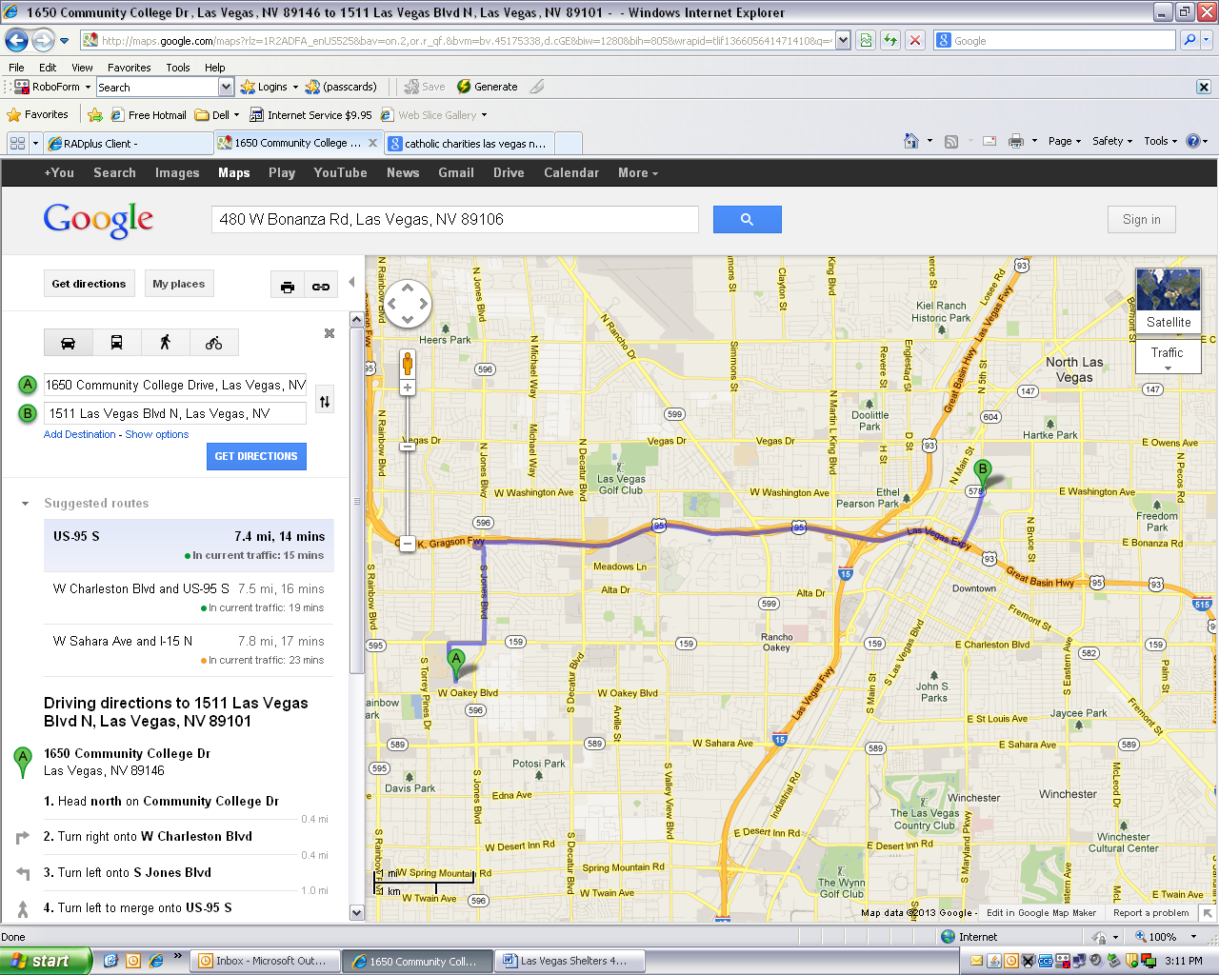

Rawson-Neal Hospital

**Las Vegas Rescue Mission/Family Shelter**: Women/Children separate from men. Women/children must report in by 3:00 pm for intake into women’s shelter. Men first come/first serve (numbers given at 3:00 pm) Men interviewed at 3:30 pm. ID required, no charge, 150 beds. No phone interviews - **480 W Bonanza Rd**.…...…………………………………………………………………….……….**382-1766**

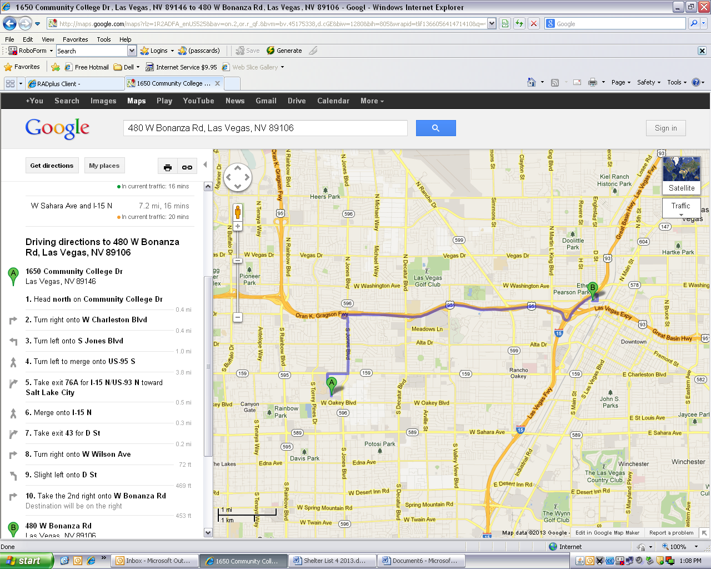

LV Rescue Mission

Rawson-Neal Hospital

**Salvation Army**: Check-in 5:00 – 6:00 pm, pay by 6:00 pm, leave next day by 6:00 am. Cost is $9.00 per night, ID required, 48 male beds, 44 female beds, Daily Resource Center free availability. Breakfast is served at 6:15 am and dinner is served at 3:45 pm. Men stay separate form women and children - **33 W Owens Ave**…………………...……………………………………**657-0123 x 26 or 27**

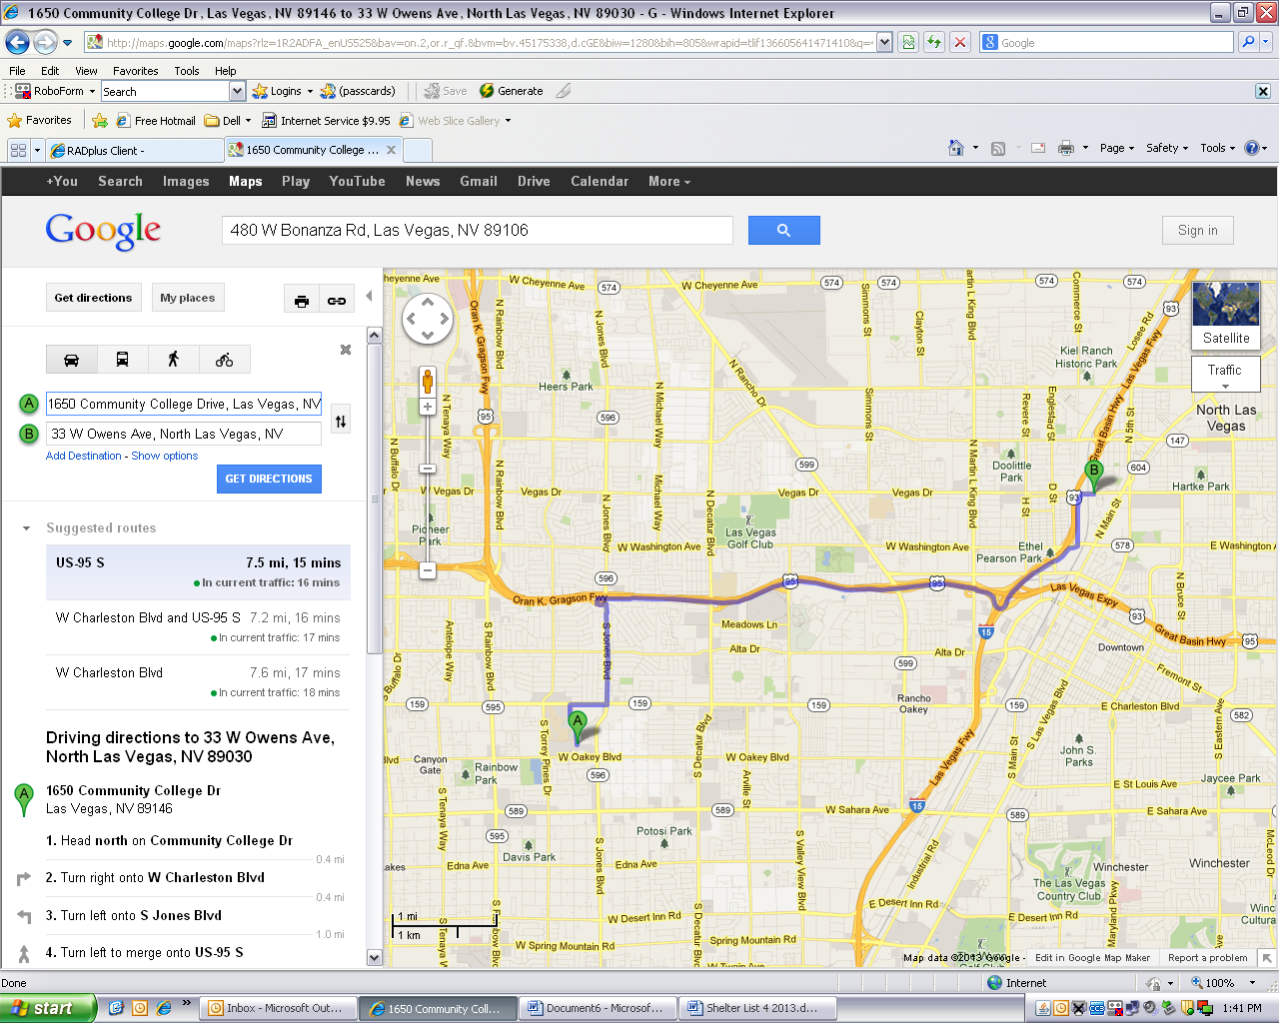

Rawson-Neal Hospital

Salvation Army

**Las Vegas Shelters**

**Shade Tree Shelter**: Shelter for women with children and single women, check in 24 hours daily, no charge for stay, would like ID but not required - **1 W Owens Ave**….……………………………………………….…………….………………....……**385-0072 or 385-4596**

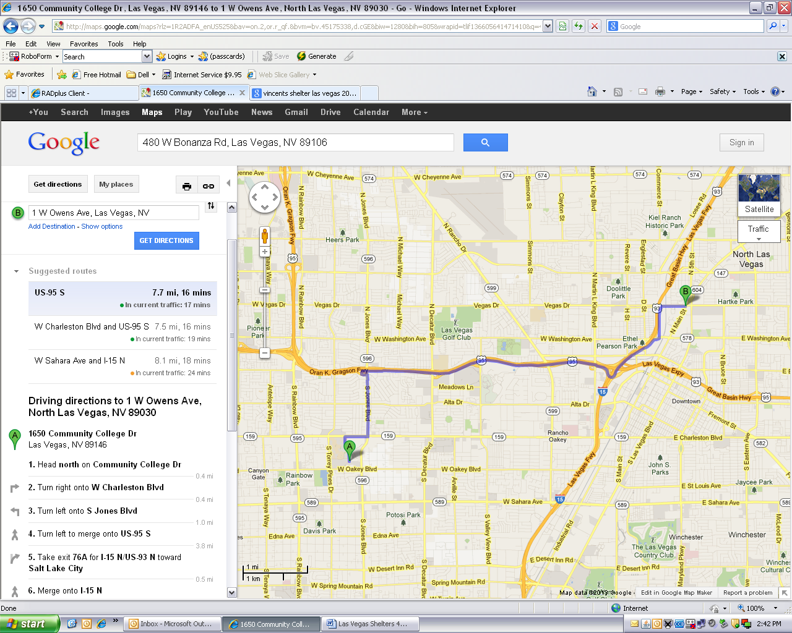

Rawson-Neal Hospital

Shade Tree Shelter

**Call for Intake:**

**Family Promise of Las Vegas**: Transitional/permanent housing program for families with children under 18, call for intake. **320 S 9th St**…………………………………………………………………...………………………...…………………..**638-8806**

**Safe Nest for Women:** Provides battered women crisis intervention, shelter and counseling.

**2915 W Charleston Ave**…………………………..………………………….………………………………….……..….**646-4981**

**S.A.F.E. House**: Provides battered women crisis intervention, shelter and counseling.….……………………….………..….……**451-4203**

**Hotline**……………………………………………………………………………………………………………..….……**564-3227**

**BRIAN SANDOVAL RICHARD WHITLEY**

**STATE OF NEVADA**

#### DIVISION OF MENTAL HEALTH AND DEVELOPMENTAL SERVICES

## SOUTHERN NEVADA ADULT MENTAL HEALTH SERVICES

**RAWSON NEAL PSYCHIATRIC HOSPITAL**

**1650 Community College Dr.**

**Las Vegas, Nevada 89146**

**(702) 486-8020**

### *Governor* *Administrator*

**MICHAEL WILLDEN CHELSEA SZKLANY**

***Director* *Hospital Administrator***

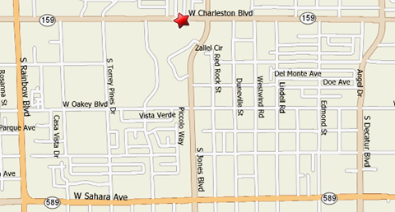

**WEST CHARLESTON CLINIC - Clinic (Intake) Phone Number 486-7107**

6161 West Charleston Blvd. Building 1, Las Vegas, NV 89146

Clinic Hours: Monday - Friday 8 AM – 5 PM, clinic is closed 2nd Friday of each month

in January, March, May, July, September, and November for State Furlough.

**Clinic doors open at 7:30 am, check-in time is 8:00 am.**

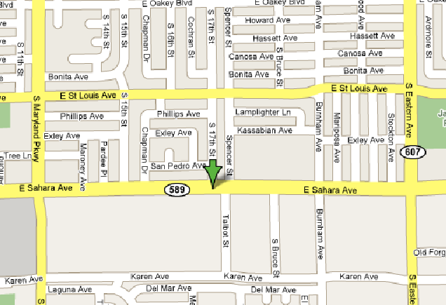

**EAST SAHARA CLINIC - Clinic Phone Number 486-6400**

1785 E Sahara, Ste #145, Las Vegas, NV 89104

Clinic Hours: Monday – Friday 8 AM – 5 PM, clinic is closed 1st Friday of each month

in January, March, May, July, September, and November for State Furlough.

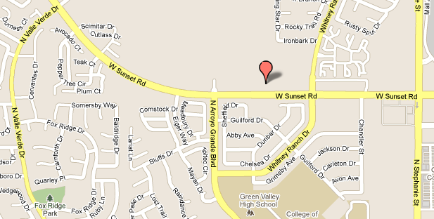

**HENDERSON CLINIC - Clinic Phone Number 486-6700**

1590 W. Sunset Road, Henderson, NV 89014

Clinic Hours: Monday – Friday 8 AM – 5 PM, clinic is closed 3rd Friday of each month

in January, March, May, July, September, and November for State Furlough.